Bellarmine University
Accessibility Resource Center
Student Guide to Accommodate

Applying for Accommodations:

To request accommodations please use this link: https://bellarmine-accommodate.symplicity.com/public_accommodation/

The form looks like this:

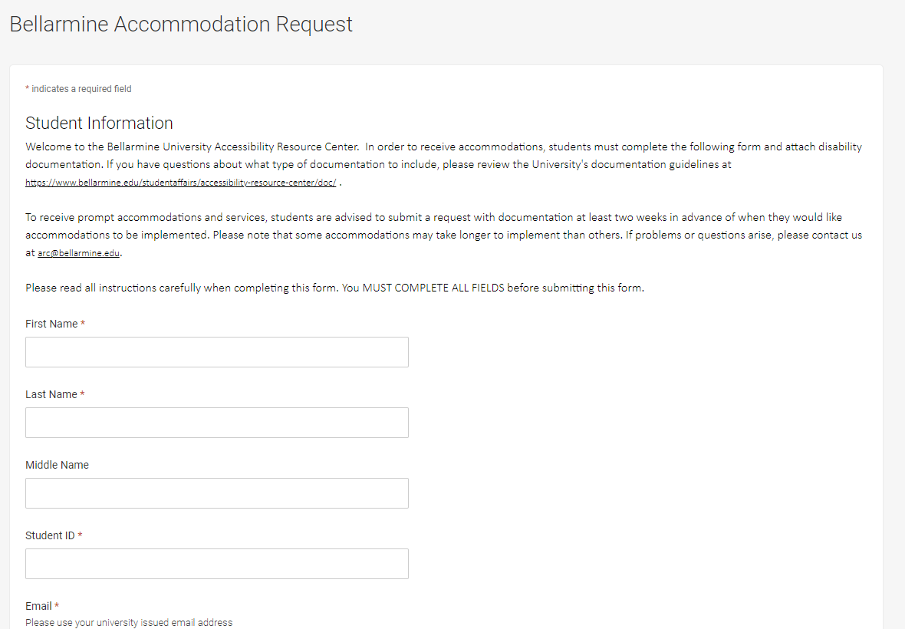

Please complete the form with as much detailed information as possible. Specifically, “how does your disability affect you academically” and “what accommodations have you used in previous academic settings”.

Accessing Accommodate:

Use this link to access Accommodate: https://bellarmine-accommodate.symplicity.com/

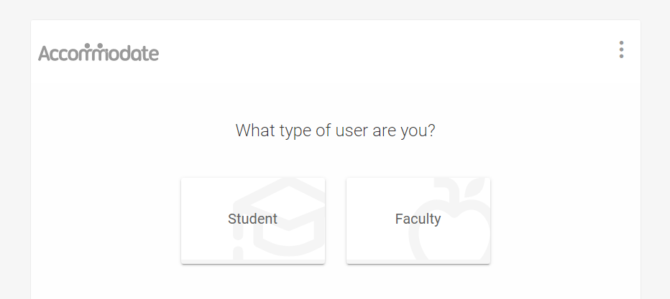

- Choose “Student”
- Log in with your OneBellarmine username and password

After logging in your home page will look like this:

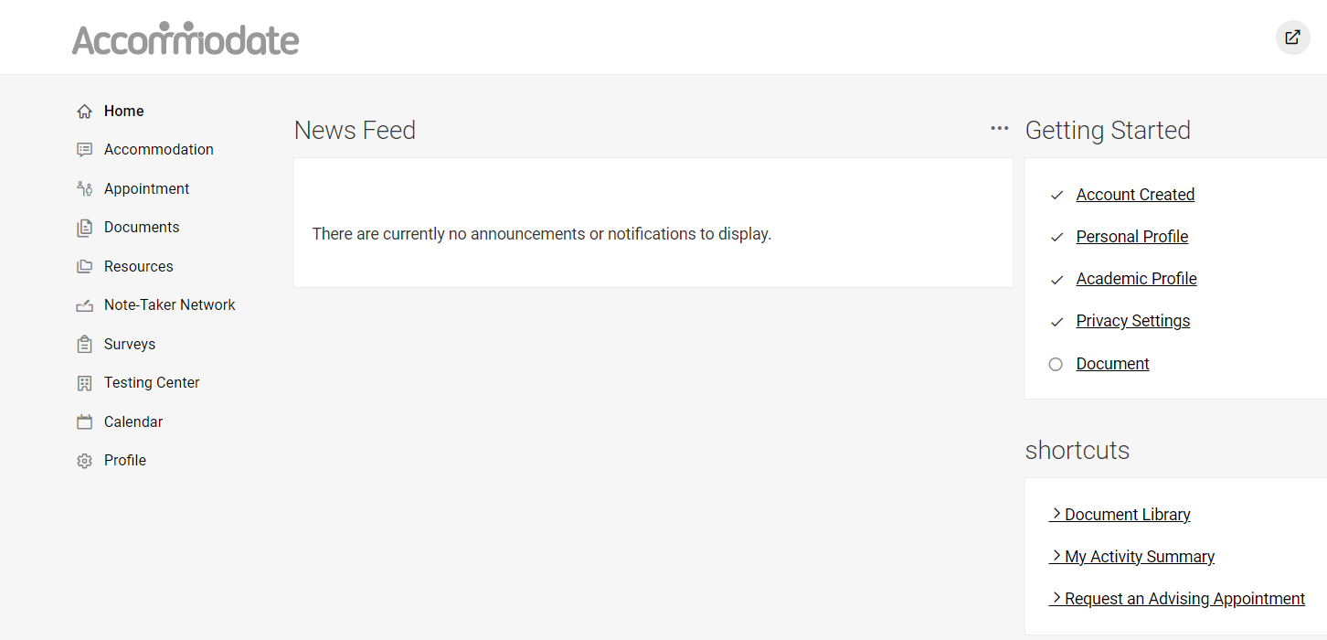

Home page features:

- Navigation tabs along the left side:
  - Home: Return to the Home page at any time
  - Accommodation: Information relating to your Accommodation Requests and all associated documents
    - Semester Request: Request to renew your accommodations at the start of each semester
    - Accommodation Letters: View current and past accommodation letters
    - Documents: Upload new documentation
  - Appointment: place to request appointments with the ARC for:
    - Initial appointments
    - Accommodation renewals
    - Follow-up consultations
    - Scribe for test
    - Reader for test

For more information on how to book an appointment, see the “Making an Appointment” section in this document.

- Profile:
  - Personal: View summary of your personal information
  - Academic: vVew summary of your academic information
  - Privacy: Where you can choose to receive email notifications, sync your calendars, and enable text message alerts from Accommodate
- There are also: “Documents, Resources, Surveys, and Calendar” tabs

NOTE: If you have been approved for note takers, or testing accommodations, you will see additional tabs.

- News Feed: announcements, system notifications
- Getting Started: jump to area
- Shortcuts: quick access to system tools

Making an appointment:

- Choose the “Appointment” tab
- Scroll down and select “Request New Appointment”

You will see this view:

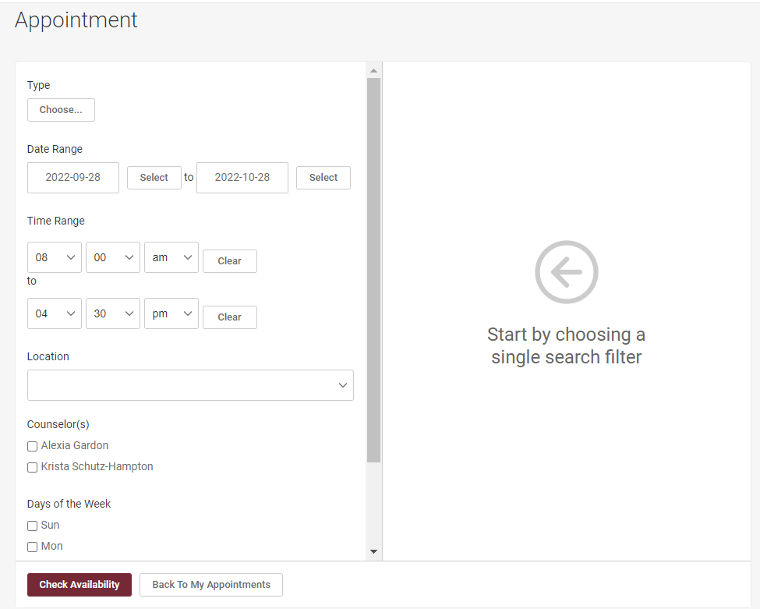

- Select the appointment type:
  - Initial Appointment (60 min)
  - Accommodation Renewal (30 min)
  - Consultation (30 min)
  - Consultation (60 min)
  - Scribe for test (60 min)
  - Reader for test (60 min)

- Choose the desired location:
  - In Person
  - Virtual / Phone Meeting
- You can refining the results by:
  - Date Range
  - Time Range
  - Counselor
  - Days of the Week

- Click “Check Availability”

- Available appointments will appear on the right hand side of the screen

- Select a time that suits you, then this screen will appear:

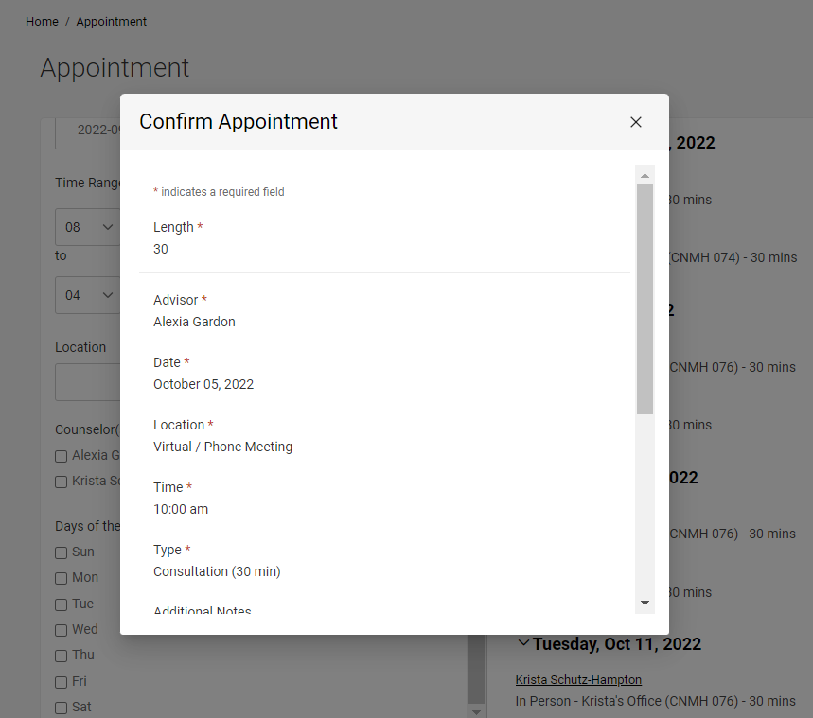

- Scroll down and click “Submit Request”

- We will review the request and either approve or reject it. After we do so, you will receive an email notification.

NOTE: If you’re having trouble finding available appointments, try clearing all search filters except appointment type.
Access to notes:

If one of your approved accommodations is to receive notes from a classmate you will see the “Note-Taker Network” tab.

- Choose the “Note-Taker Network” tab, it will look like this:

- If you receive notes for more than one course, you can narrow your results by searching by course

- All uploaded notes will appear below the “Apply Search”, “Clear”, and “More Filters” buttons

- If at any time your notes are not being uploaded in a reasonable about of time, the notes are not clear, or the notes legible please contact the Accessibility Resource Center

Manage Test Requests:

If your approved accommodations includes extended testing time and testing in a distraction-reduced environment you will see a “Testing Room” tab.

Testing Center Hours of Operation: The testing center is open Monday through Friday. The earliest you can schedule a test is 8:00 AM. Regardless of a student’s accommodations, all tests must be completed by 5:00 PM. This means you need to schedule an exam early enough in the day so that you may fully utilize the time and a half, or double time you receive.

Testing Center Policy: Students must sign up for testing center appointments 5 days prior to their requested exam date.

- Choose the “Testing Center” tab, it will look like this:

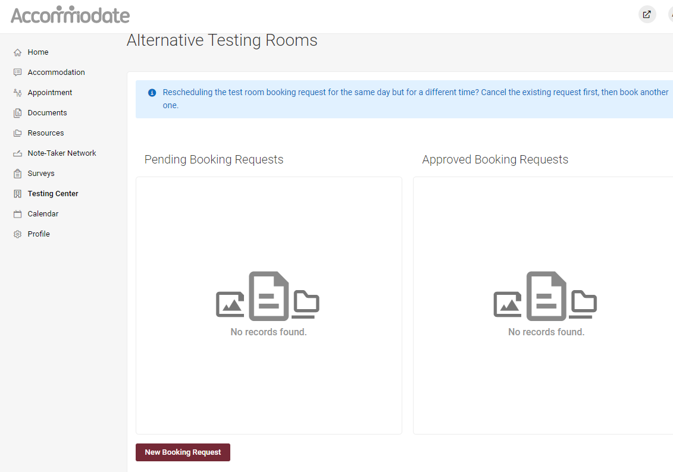

- This screen shows two types of requests:
  - Pending Booking Requests
  - Approved Booking Requests

You can view the status of your tests at any time by returning to this screen. You can also reschedule a test from this screen.

Faculty are required to approve all testing requests. Once your instructor has approved your request it will move from pending to approved.

- To request to take a test in the Testing Center, choose the “New Booking Request” button. The next screen will look like this:

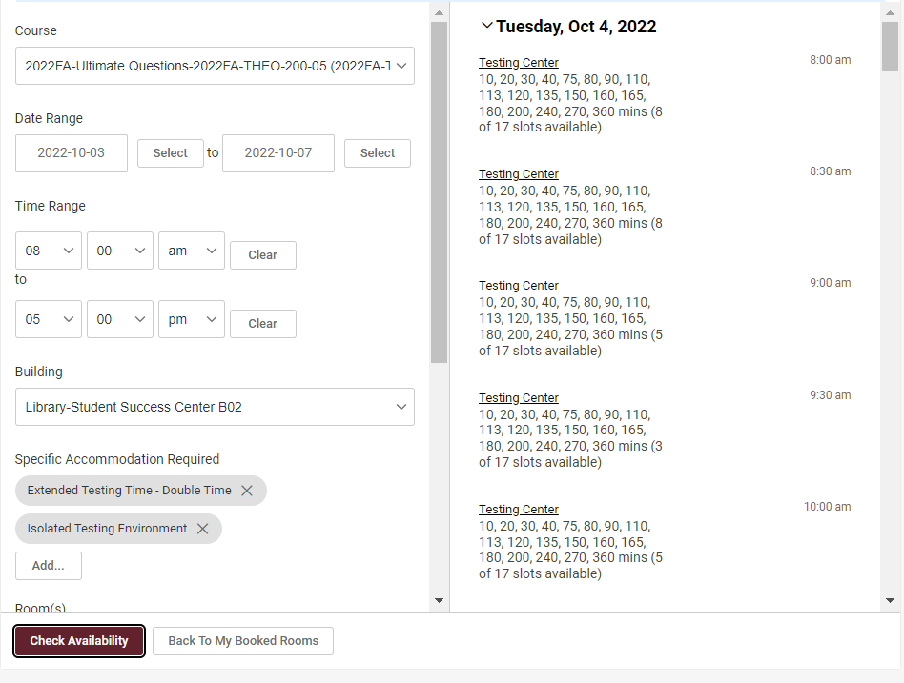

On this screen you will be able to narrow your results by:

- Date Range
- Time Range
- Days of the week

Note: the building should always be “Library-Student Success Center B02” and the Room should always be “Testing Center”.

If you make adjustments click “Check Availability” for the results to reflect the changes you have made.

- Choose the time you would like to start your test, then this screen will appear:

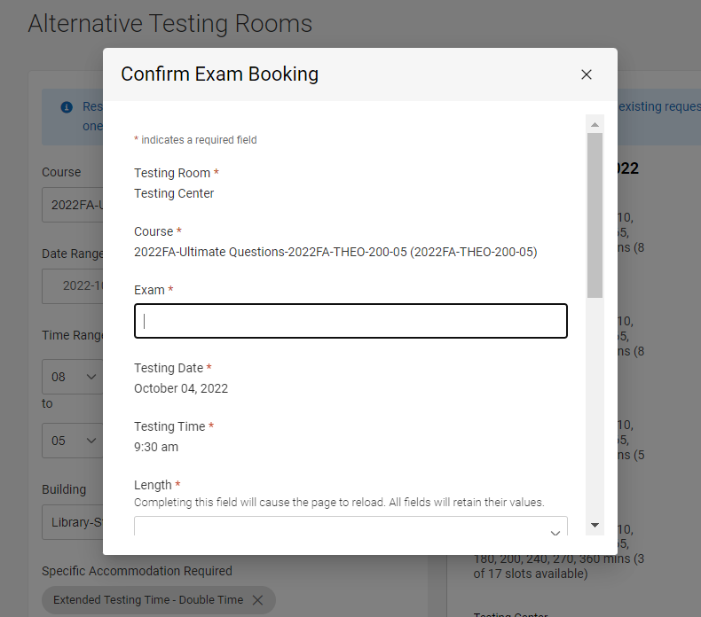

- You need to label the exam, some examples may include: Chapters 1-3, Exam 1, Final Exam, etc.

- You also need to enter the length of the exam. Calculate the length of the exam by taking the length of the class in minutes and multiplying it by 1.5 for time-and-a-half, or multiplying it by 2 for double time.

After your request has been submitted:

- Your professor will receive a notification that you have submitted a test request. They will need to approve the request no less than 24 hours prior to the testing date/time.

- Once the Testing Center has been notified of your approved request, they will ensure that you have a reserved seat in the Testing Center.

