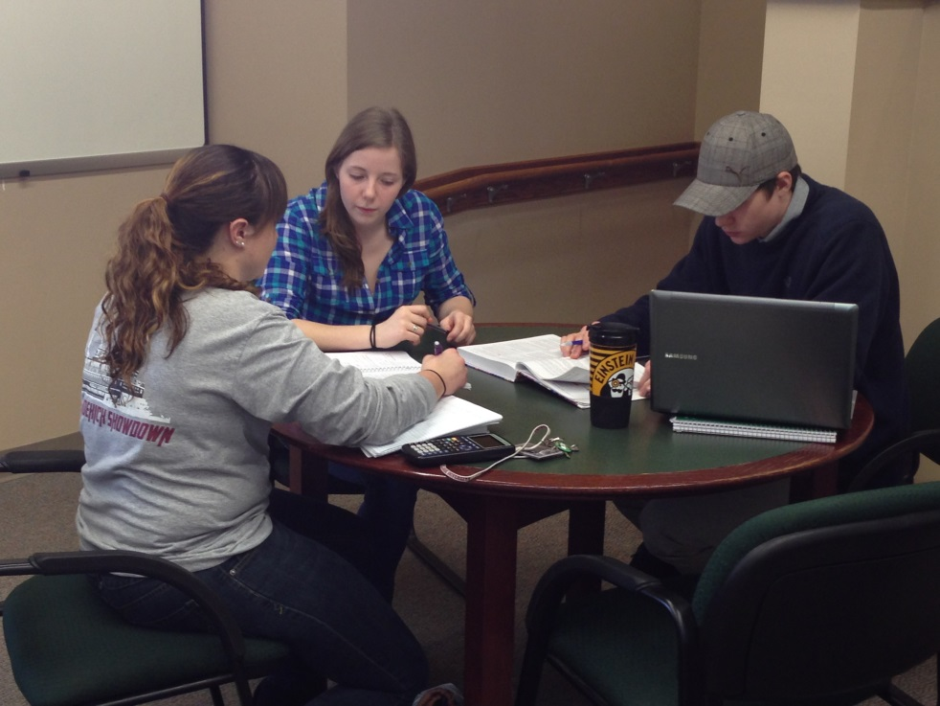

Weekly sessions will be held for the following courses:

BIOL 108, 109

CHEM 103, 104, 205, 206

NURA 205, 230, 311

Available by appointment only:

ACCT 101, 102

BIOL 300

CHEM 109

ECON 110

HIST 116, 117

MATH 116, 117, 125, 205

NURA 221

NURS 110, 200, 305

PHYS 201, 202, 205, 206

SPAN 101, 102

Need help with papers, speeches, or other written projects? check out the Writing center:

**bellarmine.edu/writingcenter**

**Courses we tutor**

**summer 2014**

To make an appointment or see our schedule of sessions, visit our website:

bellarmine.edu/ tutoring

MONDAY-THURSDAY: 8:00am - 5:00pm

FRIDAY:

8:00am - 12:00pm

For questions contact the Tutor Coordinator, Maureen McCoy, at 502-272-8453 or mmccoy@bellarmine.edu.

Appointments are subject to tutor availability. All scheduled appointments take place on the B-level of the W.L. Lyons Brown Library. Weekly sessions will be held in various locations around campus.

Check our website for details.

Need help with a class? Want to learn more about study skills and strategies? ARC tutors can help!

This summer ARC tutors will be holding weekly group sessions and scheduled sessions for select sections of 100-, 200-, and 300-level courses.

http://bellarmine.edu/tutoring

Bellarmine University Academic Resource Center | W.L. Lyons Brown Library, B-level | 502.272.7400

Enter Contact Information Here | 1127 Lombard Blvd. San Francisco, CA 59802 | phone 555.555.5555 | fax 555.555.5555

Enter Contact Information Here | 1127 Lombard Blvd. San Francisco, CA 59802 | phone 555.555.5555 | fax 555.555.5555