How to Create a PDF file.
There are a number of ways to convert your dissertation, thesis or other project into a pdf file. One of the easiest ways is to just save your file as a pdf while using Microsoft Word. In Microsoft Office 2010 (installed on computers throughout campus) follow these steps:
- Click on Save As and in the dialog box that pops up select PDF as the “Save as type” and then click on the Options button.
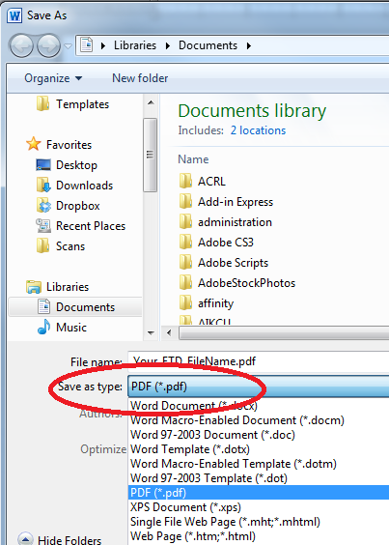
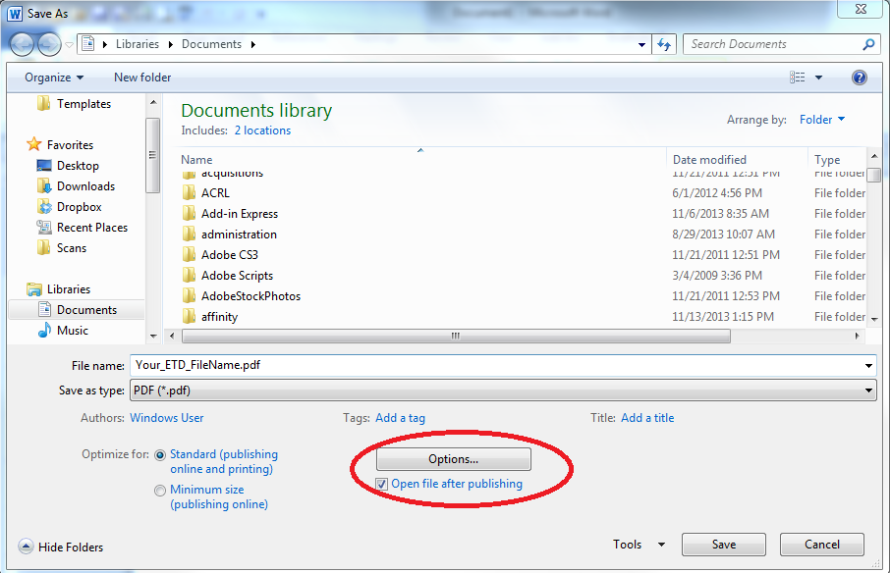
- This will bring up a new dialog box for the pdf file options. Make sure the ISO 19005-1 compliant (PDF/A) option is checked and click OK.
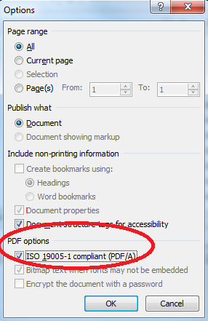
- Click on the Save button and your file will be saved as pdf and be ready for submission to Scholarworks@Bellarmine.

