Embedding fonts in your word document
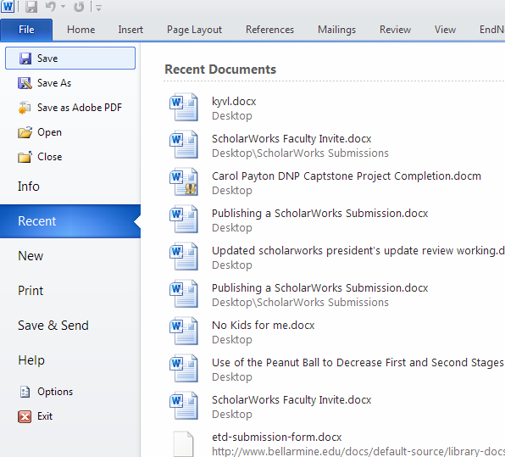

While in your Word document, click “File” tab and then select “Options” as shown above.

NEXT…
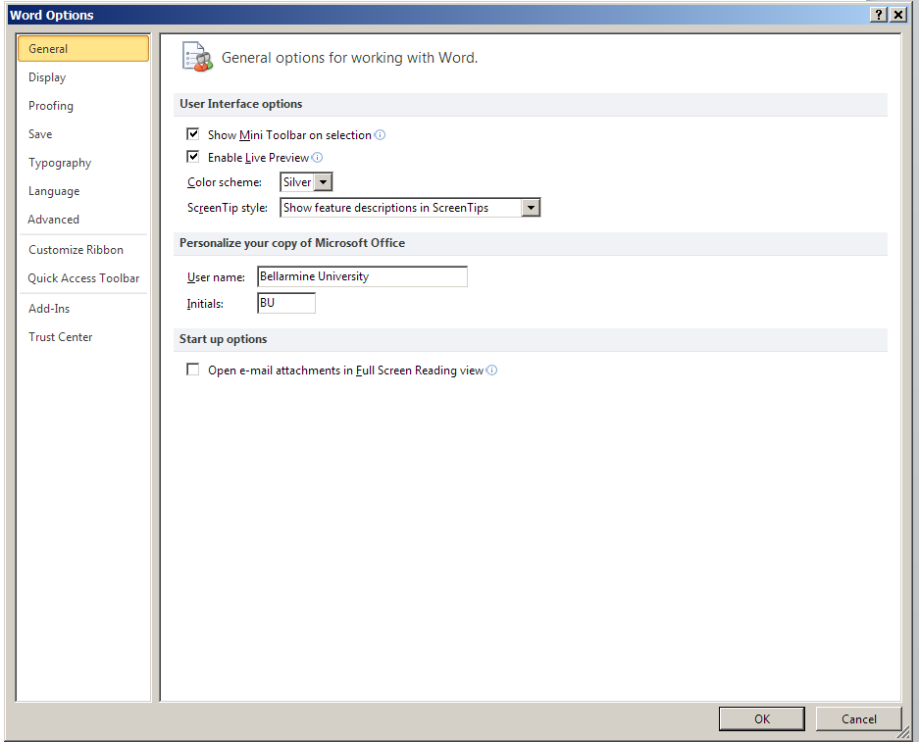

Click on “Save” in the “Options” box as shown above.

NEXT…
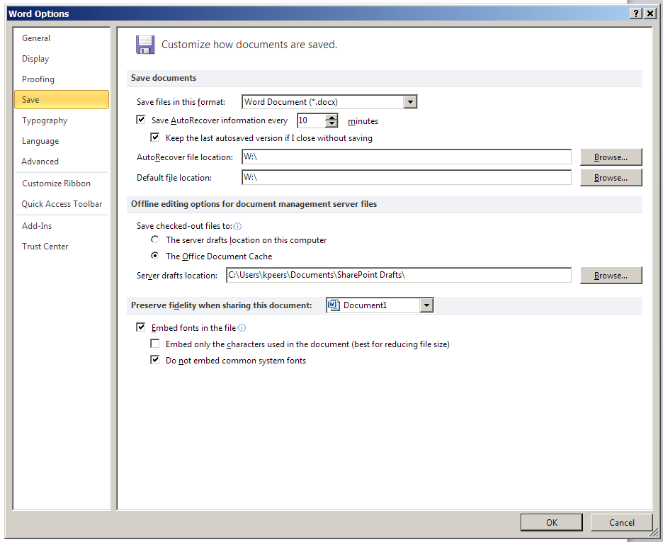

Check the box next to “Embed fonts in the file” and then click “OK”
This will embed the fonts into your document.

