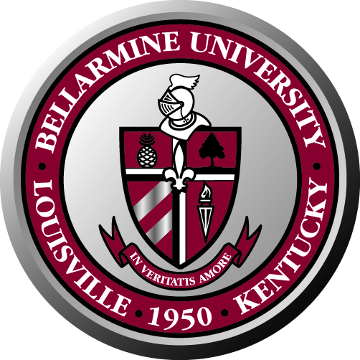
Bellarmine University Staff Council
Minutes of Meeting
October 28, 2009

The Staff Council 2008-2009 met on October 28, 2009 in the Fireplace room.

Attendance:
Present: Ken Lundgren, Ann Reed, Nettie Wilson, Pat Allen, Lynn Bynum, Lucy Burns, Marla Smith, Martha Strobel, Debbie Femi, Angela Rone, Sherry Pile, María González

Absent: Renee Hicks, Larry Modesty, Rose House, Mary Harper, Rita Yates, Hannah Clayborne, Lois Roby, Jason Zahrndt

Welcome: The meeting started with a welcome from Ken Lundgren. He also offered the prayer.

Special guests: Dr. Joseph McGowan and Beth Owen Davis

Dr. McGowan explained the error made in the CUPA calculation for this year. After looking hard for extra money, they are able to give faculty back pay for the error made.

He also said that there is no bad news regarding job losses. He also reiterated that we need new ways to get more revenue and welcomes any ideas.

The office of the President is short staffed due to Shawna Ropp’s departure. They will start a search in the coming weeks.

Beth Owen Davis talked about QEP. It was started about one and a half years ago and it is still going strong. They have several lectures scheduled for this and next semester. The next speaker is Jerry Fowler.

There is the new foreign language requirement for Bellarmine College. Also a geography initiative by Frank Hutchins to incorporate geography to the curriculum is in the works. Study abroad for faculty and students continues to grow. More international students are coming to campus and are staying longer.

Approval of Minutes: Nettie Wilson moved to approve the minutes from the April 7, 2009 meeting. Debbie Femi second. The minutes were approved without changes.

Meeting discussions:

Committee Reports:

Bylaws Committee: There wasn’t a report from this committee due to lack of time

Social and Development Committee:
- Santa Spread is scheduled for December 11, 2009.
- All is set for the Chili Cook-off on November 9, 2009. Pat Allen has cups for people who would want to have more than a taste of a particular chili.
- There will be water, tea and lemonade provided.
Benefits Committee:
- At the moment the Staff Council is not collecting for the needy.
- A plan is in the works to help a needy family.
- Staff Council members are encouraged to donate for the angel tree.

Communications Committee:
- Members were asked for help with contributions for the Staff Council Newsletter when the announcement goes out.
- The Chili Cook-off is being announced on Bellarmine Today
- New Community Exchange link is up and running on the webpage with more than thirty recipes.

Lynn Bynum:
- Tobacco cessation starts on January 1, 2010. If a staff/ faculty member is using gum or patches to help them stop smoking, the university will pay for half the cost through December 2009. This policy may be extended.
- To take advantage of this offer, the employee needs to submit an expense report to Human Resources.

Meeting was adjourned at 11:00 a.m.

