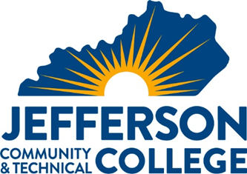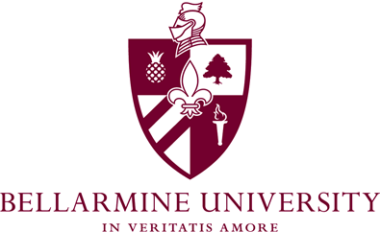

TRANSFER PATHWAY GUIDE

2021-2022
Associate in Science to Bachelors in High School Education
Chemistry Concentration

Overview
Completion of the following curriculum will satisfy the requirements for Bellarmine University at the Kentucky Community and Technical College System and leads to the Associates in Science at Jefferson Community & Technical College.

Admission Requirements
Students preparing for the teaching profession and initial teacher certification must be accepted into the teacher education program. Formal application for admission may be made upon completion of a required set of courses. Applications are obtained through the School of Education office. Transfer students desiring teacher certification must meet with the Chair to determine eligibility for admission.

General criteria for acceptance into teacher education programs are as follows:
- Evidence of specific competency levels in the following basic skills: oral and written communication, reading, writing and mathematics. Applicants to teacher education must demonstrate these competencies through their liberal arts and professional course work (including experiences in the field) and by meeting minimum score requirements on the Core Academic Skills for Educators (CASE) as follows: Reading (156), Mathematics (150), Writing (162).
- A minimum cumulative grade point average of 2.75.
- A minimum grade point average of 2.75 in the teaching major content area(s).
- A minimum grade of B- in all professional education classes, with a 2.75 cumulative grade point average in professional education courses.
- A minimum grade of C+ in ENG 101; COM 181
- Middle School majors – a minimum grade of C+ in MAT 205 and MAT 206.
- Receipt of satisfactory recommendations from instructors of Education courses, selected General Education courses, and cooperating teachers of field-based experiences.
- Appropriate teacher dispositions as delineated by the School of Education. Click here to access form.
- Code of Ethics.
- Admission interview that assesses Critical Thinking, Creativity, Collaboration, and Communication.

Degree Requirements
A minimum of 200 field hours are required prior to Student teaching. Courses may require field hours beyond regular class meetings. Additional field hours may be required.

Additional Information
Student’s may choose to double major with AAS in Education and Associates in Science to maximize the number of courses taken at Jefferson and transferred to Bellarmine. Speak with your Jefferson advisor for details. *Courses will not meet additional field hours requirements.
Students are highly encouraged to take EDP 202, EDP 260, CHE 280 & CHE 285 at Jefferson if they have the financial means to pay for courses.

KCTCS AS to Bachelors in High School Education- Chemistry Concentration CHECKLIST

Jefferson Community and Technical College

Category 1: KCTCS General Education Core Requirements (33 hours)
KCTCS Course | Course or Category | Credits | Bellarmine  Course | Completed
ENG 101 | Written Communication I | 3 | ENGL 101
ENG 102 | Written Communication II | 3 | ENGL Elective
COM 181 | Basic Public Speaking | 3 | COMM 103
PSY 110 | General Psychology | 3 | PSYC 103
REL 130 | Intro. to Comparative Religion | 3 | THEO 200
HIS 101 or HIS 102 | World Civilization I or World Civilization II | 3 | HIST 116 or  HIST 117
PHI 100 | Intro. to Philosophy | 3 | PHIL 101
CHE 170 &  CHE 175 | General Chemistry I & lab | 5 | CHEM 103 & CHEM 103L
CHE 180 &  CHE 185 | General Chemistry II & Lab | 5 | CHEM 104 & CHEM 104L
MAT 175 | Calculus I | 5 | MATH 117
MAT 185 | Calculus II | 5 | MATH 118
 | Subtotal General Education Core Courses | 41

Category 2: KCTCS AS Requirements (6 hours)
KCTCS Course | Course or Category | Credits | Bellarmine  Course | Completed
PHY 231 & PHY 241 | General University Physics I & Lab | 5 | PHY 205 &  PHY 205L
CHE 270 & CHE 275 | Organic Chemistry I & lab | 5 | CHEM 205 & CHEM 205L
 | Subtotal AA/AS Requirement Courses | 10

Category 3: KCTCS Electives (21 hours)
KCTCS Course | Course or Category | Credits | Bellarmine  Course | Completed
FYE 105 | First-Year Experience | 3 | GEN- Elective
EDU 204 | Technology in the Classroom | 3 | EDUC 316
EDU 201 | Intro. to American Education | 3 | EDUC 200
 | Subtotal Elective Courses | 9
 | TOTAL Associate Degree Hours | 60
** Students must demonstrate computer/digital literacy skills, either through completing a course or passing the IC3 test.

Double Major Option
AS and AAS in Education

Additional courses needed for AAS in Education
Jefferson Course | Course | Credits | Bellarmine Course | Notes
EDP 202 | Human Development and Learning | 3 | EDUC 221 | Should take after completing AS degree to be eligible for Financial Aid
EDP 260 | Motivation & Classroom Management | 3 | EDUC 355
HIS 108 or 109 | History of the US thru 1865 or  History of US since 1865 | 3 | HIST 201 or HIST 202
Subtotal {Institution} Credit Hours |  | 60

Additional course for AAS degree were suggested to be take as part of the AS to meet both degree requirements.

Updated: Oct. 2021

