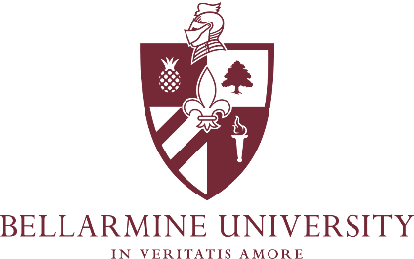

Fall Semester 2023
OnCourse Program

Welcome First Year Students and continuing students! Below are VERY IMPORTANT dates and information regarding your Summer Semester course materials.

Digital Textbooks:
- If an e-book format is available for any of your required course material titles, you may access them at https://brytewave.redshelf.com or follow the directions sent to your Bellarmine email address.

Added Classes:
- If you add a new class, and physical materials are required, please pick up your materials inside Hilary’s once you receive an email that your order is ready for pickup. If you add a course after September 1, you will pick up your materials inside the Bellarmine Campus Store.

Dropped & Cancelled Classes:
- If you drop a class (including section changes) or withdraw from the program, please make sure to return all course materials to the Bellarmine Campus Store immediately. Do not hold onto the course materials until the end of the term. Fall returns must be completed within one week from the start of the course. The deadline to return dropped materials is September 1, 2023.
- When returning course materials, please make sure the following conditions are met:
  - New books must be returned in new condition
  - Packages must be unopened
  - Access codes must be unopened and unused

After Final Exams / End of Semester Textbook Rental Return:
- All rental books must be returned to the Bellarmine Campus Store by December 8, 2023.
- If you wish to keep a book, or if a book is lost or damaged, you may convert the book to purchase at the Bellarmine Campus Store at any time throughout the semester by paying an additional fee. The deadline to convert to purchase is December 8, 2023.
- A free shipping label is available via your rental reminder email 14 days prior to due date. If you need to ship the materials to the store prior to this email communication, postage is the expense of the student. Please make sure to include your name, email, and phone number on a piece of paper inside of the box. The address is:

Bellarmine Campus Store
2001 Newburg Road
Horrigan Hall Louisville, KY 40205

OnCourse Included Course Material Policy

REASON FOR POLICY
  - This policy provides procedures and guidelines for the OnCourse Included Course Material program for Bellarmine University. These procedures follow a fair and equitable process that aligns with the mission and values of the University as it relates to student success for included course materials. OnCourse is committed to service for the entire Bellarmine University community of students, faculty, and staff to provide our students with the required materials needed in the classroom.

POLICY
  - Below are the OnCourse policies and are in effect and approved by Bellarmine University. It is the individual’s responsibility to understand and comply with all policies published. Failure to abide by these policies is not a valid excuse for violation of any OnCourse regulations.
  - These policies are subject to change. The Exhibits herein contain information that may vary from year to year and are subject to change without the policy itself necessarily being modified.

- All physical rented textbooks are due back by the Friday of finals week. Rented textbooks are available to convert to a purchase for an additional fee. Any rented textbook not returned or converted to a purchase by the Friday of finals week is subject to a non- return course material fine. The deadline for Fall is December 8, 2023. This fine is based on the book and varies. Please contact the Campus Store for specific penalties per book.

- All dropped classes must have physical course materials returned within one week from the start of the course. This includes courses dropped for section changes. Failure to return all dropped course materials (in the same condition they were provided) by the deadline will result in a drop-class non-return fine placed onto the student's Bursar account per class. Any dropped material that is a rental and is not returned by the drop deadline is still due by Friday of finals week and subject to the additional course-material non-return fine.

- The last day to pick up any physical course materials from the Bellarmine Campus Store is October 20, 2023. Any physical materials not picked up by this date will be returned on behalf of the student and unavailable to be picked up.

Students who want to ensure that OnCourse complies with specific accommodations they require should contact the Office of Disability Services at 502.272.8490.

