Holiday Craft Instructions and Materials

Citrasolv Image Transfer
Citrasolv is a natural, citrus-based concentrated cleaner/solvent that many artists and crafters use to transfer laser images from plain paper onto other surfaces. Citrasolv is non-toxic, but the smell is strong. I recommend working in a ventilated area or keeping the lid on the bottle whenever it’s not in use. Citrasolv is available at many hardware, craft and natural food stores (call ahead to ensure it’s in stock) and online.

Materials
- Citrasolv
- Toner printout or copy: Experiment. Most toner laser prints and copies should work, but not all will. I have successfully used printouts from our black-andwhite HP LaserJet 1022n home printer and copies made at FedEx and other places. While some color printouts work, I’ve had better luck with black-and-white laser prints.
- Final Print Surface: This can be paper (something with a slightly rough or matte surface works best), raw wood, leather or natural fabrics such as cotton canvas and linen. You can experiment with other surfaces primed with acrylic paint.
- Applicator: This can be a cotton ball, brush, sponge brush, paper towel, etc.
- Spoon or similar object for burnishing
- Low-stick tape: Blue masking tape or drafting tape work well.

Steps

- Create and print (or copy) your design. If there’s text, you’ll need to reverse the image before printing. This can be done in Microsoft Word or a number of other programs.

To flip an image in Word:
- Drag the image into a new Word document window or use the Insert menu to browse to “Pictures” and then “Picture from File.”.
- Once it’s in the Word document, select the image by clicking on it.
- Adjust the size as needed by pulling on one of the squares (anchors) that appear at the corners of the image.
- Choose the Picture Format tab that appears when the image is selected.
- Look for the Rotate drop-down menu. You may need to maximize the Word window to find it easily. See the illustration.
- Choose “Flip Horizontal.”
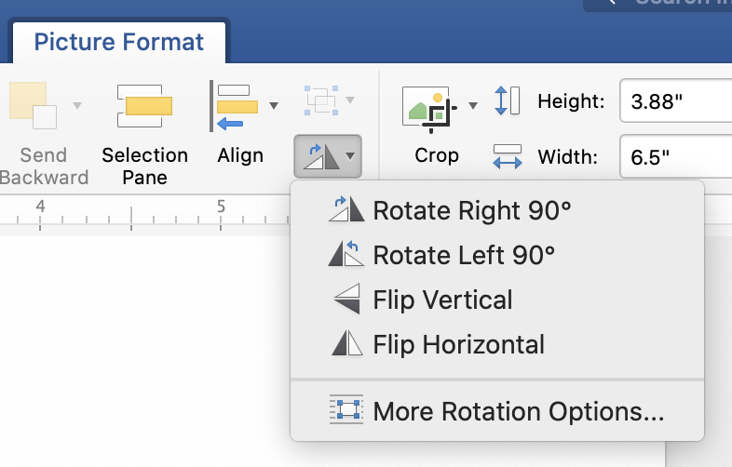

- To keep it secure as you transfer, tape down the paper or other material you’re transferring onto as needed.

- Tape your printout or copy facedown on top of the paper or material you’re going to transfer onto. Pins work well if you’re transferring onto fabric. I usually apply tape at all corners so that the image stays aligned if I peel it back to check on it. This also helps maintain alignment if the print distorts when wet.

- Apply Citrasolv to your applicator. (Too much Citrasolv can cause your image to smear, especially on smooth surfaces.) I use a cotton ball as an applicator so that I can squeeze out excess Citrasolv before applying it.

- Coat the back of your printout or copy with the Citrasolv. Try a light coat, just enough to make the printout or copy paper translucent enough to see the entire image through it.

- Use the back of the spoon to rub on the printout and transfer the image. Peel back parts of the image as needed to check your progress.

That’s it!

Basic Japanese Stab Book Binding
A fun, easy way to make homemade books, albums, sketchpads, etc. This is also a great way to create books with creative features such as pockets and fold-out pages from ephemera such as maps, playbills and brochures.

Materials

- Paper pages
- Cover Material: Use cardstock or something similar if you want a cover that’s a bit heavier than the rest of the paper.
- Binder clips
- Awl, screw punch, or drill with small bit
- Bookbinders needles: I use Lineco Binders needles. They come in packs of five.
- Waxed linen thread: I use the Books By Hand brand

Steps

- Cut your covers and other pages down to size as needed.

- Measure where to punch your holes. I usually space my holes evenly approximately ½ inch from each other and ½ inch from the spine edge of the book.

- Punch your holes either all at once (see “a”) or in small batches (see “b”). Make the holes large enough so that the thread can pass through each of them three times.

  - Mark the holes on one of your two covers. Use binder clips to hold all the book pages together and a drill or awl to punch through all the pages at once. I suggest padding the binder clips with something (tissue, cotton, extra paper) to keep them from leaving divot marks on your book.

  - Alternately, I find it easier and neater to punch through a number of small stacks of the paper using a screw punch tool. Create a template by measuring and punching the holes in a single sheet of cardstock. Gather your paper into stacks of about five sheets each (depending on the quality of the screw punch tool) and use the template to mark where the holes should be on the top sheet of each stack. Use small binder clips to hold each stack together while you punch the holes. Once done, align all that stacks and use binder clips to hold everything in place.

- Thread your needle with a length of waxed linen about 5 ttimes the height of the book spine, depending on the thickness of your book. Too much is better than too little.

- Insert the threaded needle from the back of the book through the second-to-bottom hole. Pull the thread all the way through the book, leaving about two inches of thread at the end to tie off when you’re done.

- Bring the threaded needle all the way around the spine and through the same hole from the back again once, creating a tight loop around the spine.

- Move up to the next hole. Insert the threaded needle from the front of the book into the third hole from the bottom. Loop around again and reinsert the needle through the front of the third hole.

- Move up to the fourth hole, inserting the needle from the back of the book and looping around. Continue this pattern all the way up the spine.

- Once you’ve looped the thread at the top hole all the way around the spine, loop it again around the top of the book edge and into the same hole.

- Thread your way back down the spine by simply running the thread in one hole and out the next (like a running stitch). In this way, the thread should “fill in” the alternating spaces on each side of the spine where there are gaps with no thread.

- Once you get to the bottom hole, loop the thread around the spine (and back into the bottom hole) then around the bottom of the book (and back into the same bottom hole again).

- There should now be one remaining gap in thread at the back of the book between the bottom and second-from-bottom hole. Thread the needle between the back cover of the book and the first loop you created around the spine (at the second-from-bottom hole). Tightly tie off the two ends of the thread and cut off the excess. If desired, you can press the knot down into the hole to hide it bit.

And you’re done!

