**Additionally: You CAN record online lectures using Sonocent.**

COMPUTER:  Using Sonocent (on your computer) for online lecture is very similar to face-to-face lecture.

* The main difference is that instead of selecting BLANK PROJECT on the home screen, you select RECORDING FROM SPEAKERS ONLY.  **NOTE—This feature is NOT available on Mac computers, but there are ways to work around this; see below.**

* For more details and to see video instruction use this link à [https://www.loom.com/share/5311b5e1cff24beea0f1c0c53c7ff89b](https://nam10.safelinks.protection.outlook.com/?url=https%3A%2F%2Fwww.loom.com%2Fshare%2F5311b5e1cff24beea0f1c0c53c7ff89b&data=02%7C01%7Cjvoigt%40bellarmine.edu%7C2c43bc42eece4ea963d308d7cf5f86ed%7C5290229cd9f145dca0d4263790f731fa%7C1%7C0%7C637205881496966460&sdata=CeByEzk8Lw85LwrB7Y%2FXxuwriZqrp%2FqjuFceT2xO%2BsY%3D&reserved=0)

* (See example picture below—a red circle is around ‘recording from speakers only.’)

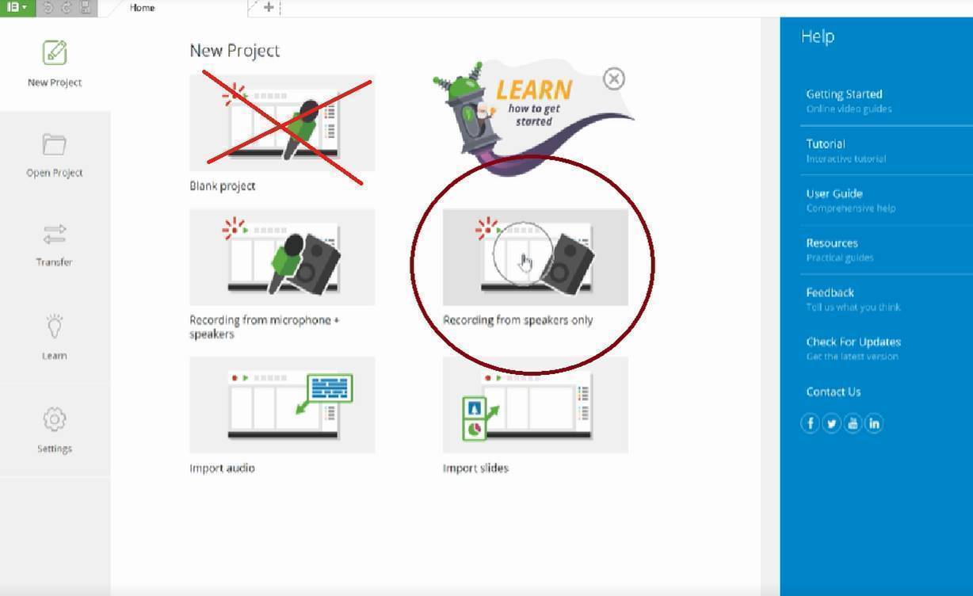

Using Sonocent remotely with a Mac computer:

* You can stream and record online content through the microphone of either the laptop or by using a mobile device. To record from a mobile device, watch the lecture on your computer, and use the Sonocent Link app to record the lecture on your phone or ipad.
* If recording from the microphone, this will be similar to using Sonocent as you would live in class but you may need to cleanup the audio afterwards.
* Go to the ‘audio-cleanup’ drop down menu and adjust the audio recording as needed.

Sonocent Link Application on ipad/iphone/other devices:

* The option to ‘record from speakers only’ is NOT available via Sonocent Link App.  You can still use the app, but you cannot listen to a lecture and record a lecture on the same device using Sonocent Link
* The lecture would need to be listened to on one device, and then you could use the Sonocent link recorder on a separate device, almost like you are in a face-to-face lecture