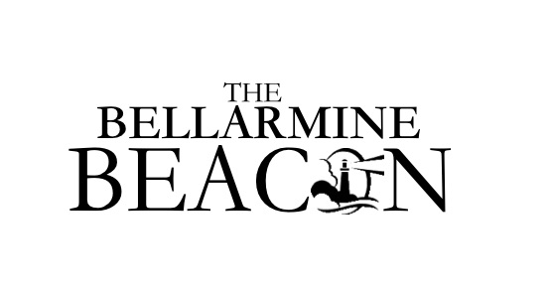

SUBMISSION FORM

Please submit ALL publications to the submission box in Siena Terzo 114 NO LATER than NOON the day before the article is to run!

Name of submitter:

Date of submission: Time of submission:

Date(s) to run (start to end):

How do you want the article to read? Please include all relevant information, such as who/what/where/when:

Please remember that The Bellarmine Beacon is for INFORMATION and ANNOUNCEMENTS only. The Bellarmine Beacon is not published on weekends. All articles to be published on Monday MUST be turned in by NOON on Friday.

For questions, see Briar Honeycutt in the Main Office located in Siena Terzo Lobby.

