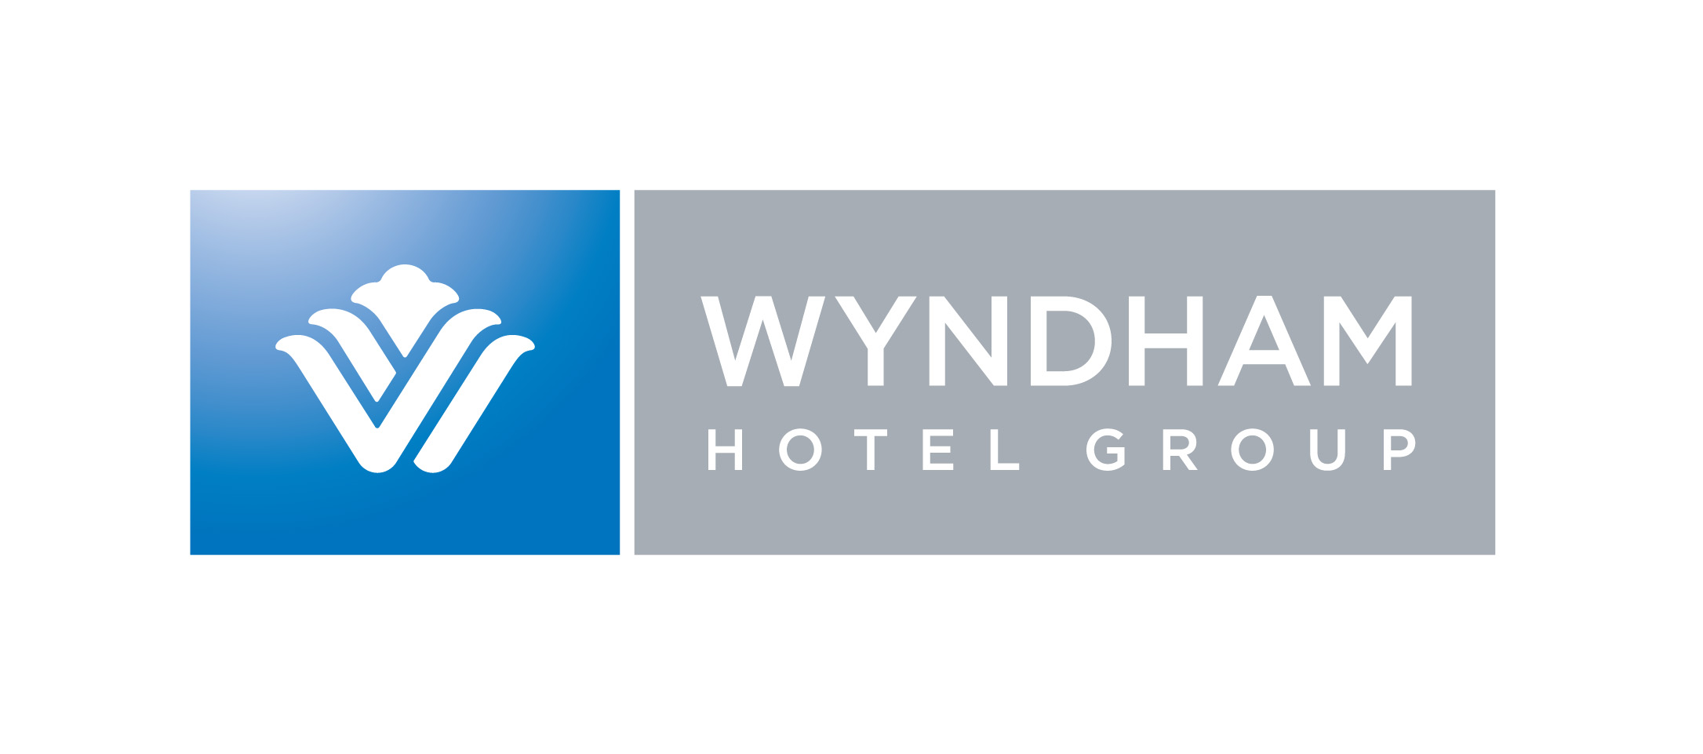

Program Fact Sheet

Program Name: E and I Cooperative Purchasing
For: Bellarmine University
Discount Account ID Number: 1000007780
Affiliate ID Number: 000370

Toll Free Numbers

Your members may use the following toll free number to book their discounted hotel stays. Upon calling the number, the agent will prompt your member to provide the specific discount ID code (as displayed above) and your institution’s personal member ID to receive the discount and track usage. Discounts are applied at time of booking and are not backed out of bill upon checking out of hotel.

Days Inn®
Howard Johnson®
Knights Inn®
Ramada®
Super 8®
Travelodge®
Wingate By Wyndham®
Wyndham Hotels and Resorts
Baymont Inns and Suites®
Microtel Inns and Suites®
Hawthorn Suites®

Toll free Number is 800-525-5501

URL Request

To optimally promote your program, you should consider an online booking capability. I would encourage you to post these URL hot links from your intranet website to our booking site. This link pre-populates your ID number into the reservation to deliver the discounted rate and track the reservation.

All brands except Wyndham Hotels and Resorts

https://wr.wyndhamrewards.com/WyndhamRewards/control/advanced_search?client_account2=1000007780&affilid=000370

Wyndham Hotels and Resorts

http://www.wyndham.com/rates/main.wnt?corporateid=1000007780

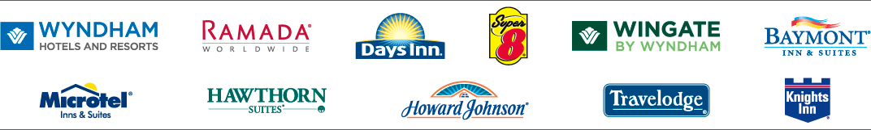

Brand Descriptions

Wyndham Hotel Group

The Wyndham Hotel Group is one of the world’s largest integrated hotel franchise and management companies. It includes 11 hotel brands representing nearly 7,000 hotels and more than 535,000 hotel rooms on six continents.

The following entries are the approved description copy for each brand. These may be used in promoting each brand on either print or web site promotions.

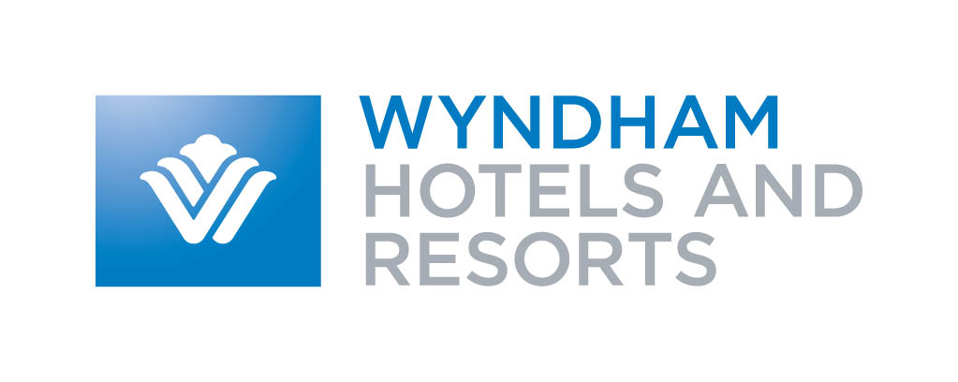
Wyndham Hotels and Resorts is an innovative, upscale hotel brand with nearly 100 properties located in the U.S., Canada, the United Kingdom, the Caribbean and Mexico. Viva Wyndham Resorts, a collection of all-inclusive resorts, are clustered in the Caribbean and Mexico. Each Wyndham guest room includes a coffeemaker, a choice of hypoallergenic pillows, shower massagers, complimentary weekday newspaper and upscale bath amenities. Most Wyndham properties feature in-room dining, signature restaurants, upgraded bedding, Herman Miller® ergonomic desk chairs, high-speed Internet access and cordless phones.
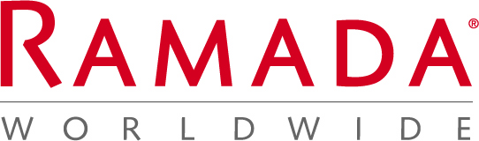

This is an exciting time for Ramada Worldwide, Inc. as the brand now offers over 1,000 hotel locations throughout the world. There are more tremendous changes on the horizon for Ramada®, which continues to build on years of consumer recognition, confidence and loyalty.

In North America, Ramada offers four distinct tiers of service. The Ramada Plazas offer premier properties designed for discerning travelers with a contemporary décor. The Ramada Inns offer high-quality hotels featuring accommodations for the mid-market traveler with swimming pools at most locations, restaurants or a-la-carte food service and enhanced continental breakfast, In Canada, the Ramada Hotels include Mid-priced, full-service properties, conveniently located near city centers or airports with restaurants, lounges, enhanced continental breakfast and swimming pools. For the value conscious, Ramada Limiteds feature high-quality accommodations at value prices which includes free continental breakfast, newly enhanced with more variety, and swimming pools at most locations

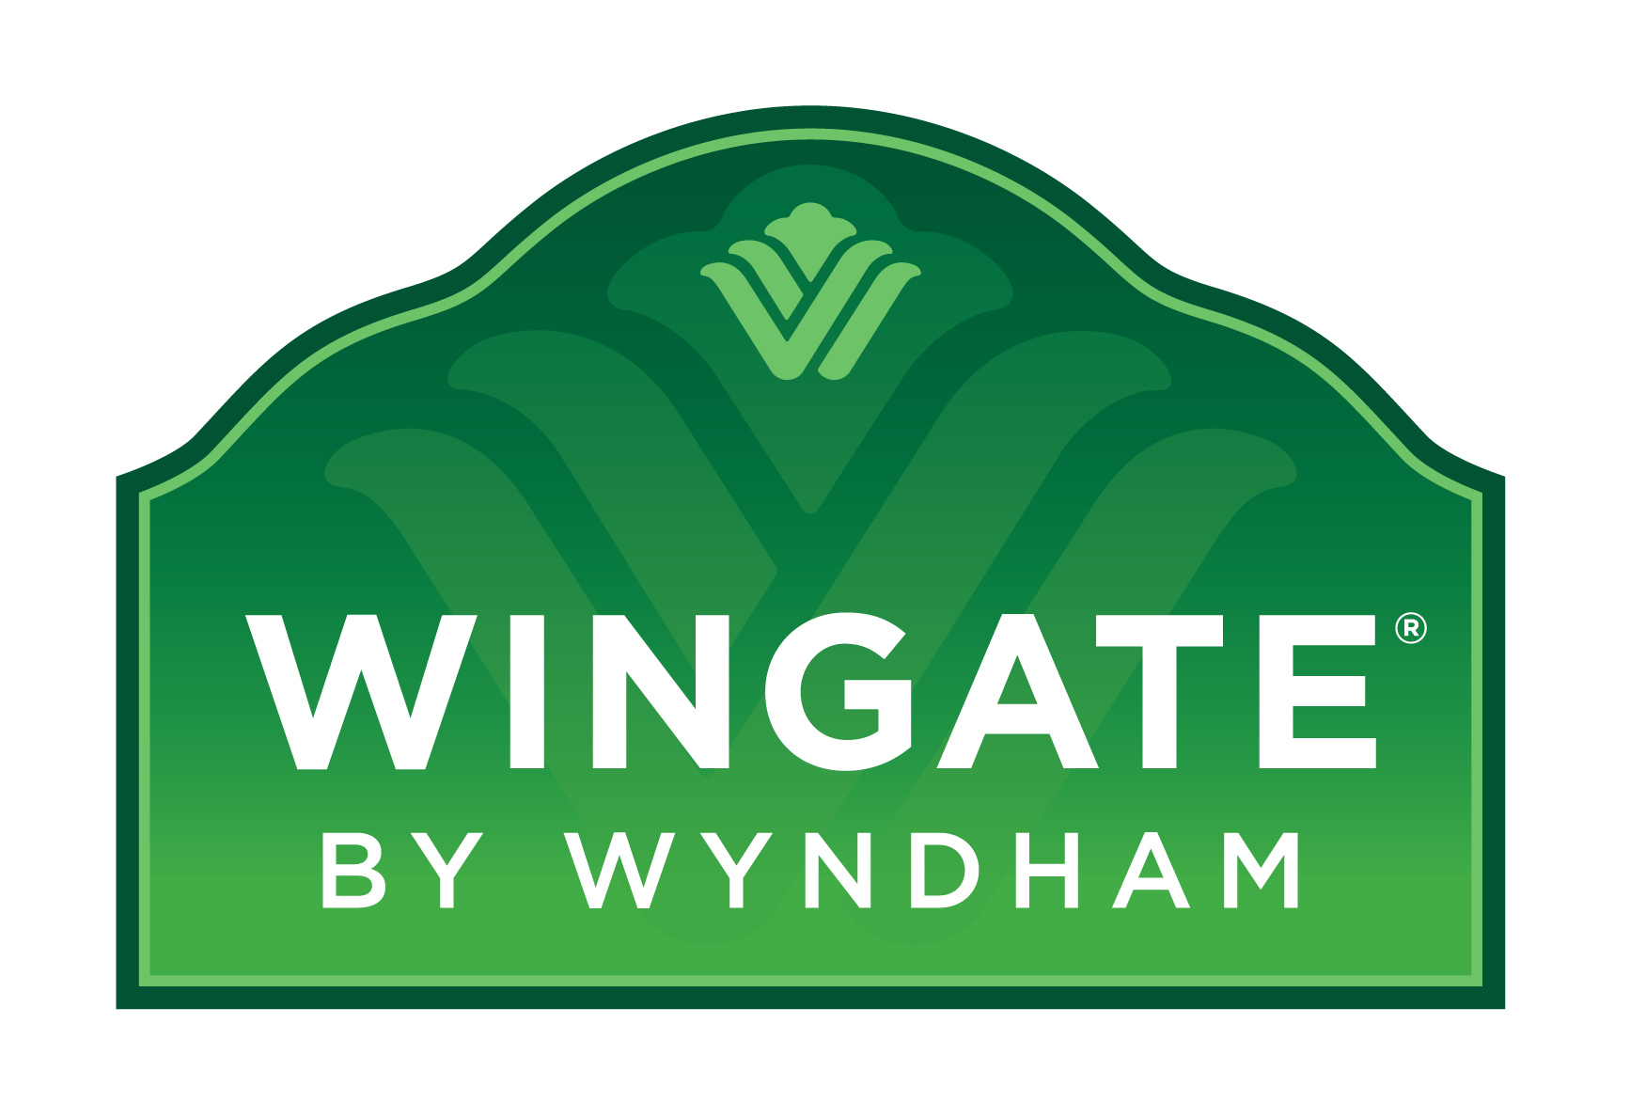
Wingate By Wyndham® hotels are built for business offering oversized guest rooms each with free high-speed wired and wireless Internet access at over 150 locations. Enjoy extensive complimentary amenities such as: expanded continental breakfast, fitness room with whirlpool, use of the 24-hour self-serve business center with free faxes, copies and printing, free local calls and long distance access. These original, new-construction-only hotels feature a luxurious shower experience with Moen Revolution showerhead, curved shower rod and hook-less shower curtain. You will also enjoy the new bed experience featuring top-of-the-line mattress and box spring and more plush pillows and linens.

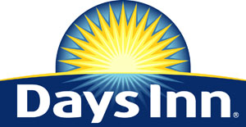

The Best value under the Sun.SM Days Inns Worldwide was founded on the basic principles of friendly, courteous service and clean comfortable rooms. Today, the Days Inn® brand remains just as committed to providing our guests with a warm and welcoming environment each and every time they stay with us. From free high-speed internet, and its SolTerre® Shower Experience and SolTerre® Sleep Experience to its complimentary Daybreak® Breakfast, Days Inn®, and its 1,900 hotels worldwide, offers the best value for price-conscience travelers everywhere under the sun!

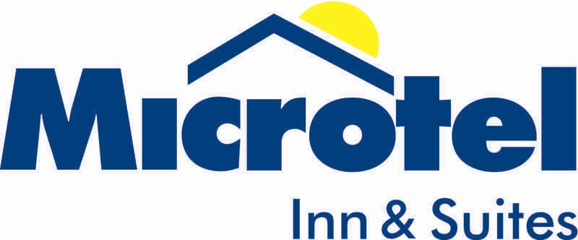

For an unprecedented seventh consecutive year, Microtel has been ranked “Highest in Guest Satisfaction Among Economy/Budget Hotel Chains” in the J.D. Power and Associates 2008 North America Hotel Guest Satisfaction Index StudySM. Hotels offer Free local and long distance phone calls within the continental U.S., Free wireless high-speed Internet access, Free Get Up & JoeSM continental breakfast, Dream WellTM, Microtel’s stylish new high quality bedding, Remote cable TV with ESPN, CNN and one free movie channel, and Compact refrigerator, microwave and coffeemaker in all suites.

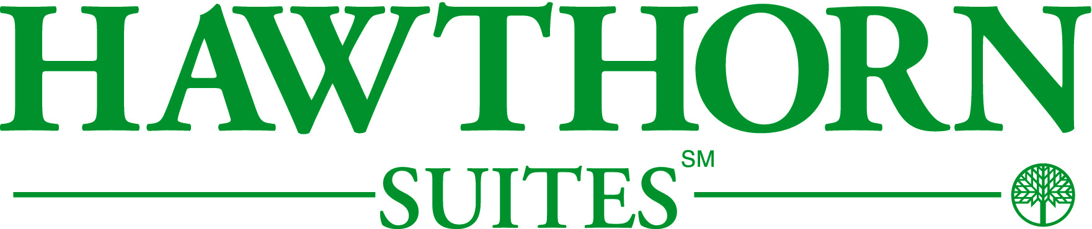
Hawthorn Suites — the all-suites, extended stay hotel brand — takes pride in being a home-away-from-home. All Hawthorn Suites hotels feature studio, one-and-two-bedroom suites and offer complimentary hot breakfast buffet, daily newspaper, meeting space, pool, spa, exercise facilities, convenience store and guest laundry. Suites feature complimentary high-speed wired and wireless Internet access, fully equipped kitchen or wet-bar kitchen and premium television channels. Select properties allow pets. Business and leisure travelers alike appreciate Hawthorn's daily complimentary signature hot breakfast buffet and Wednesday evening social hour, free Wi-Fi and expanded cable television, on-site convenience store, valet and grocery shopping services.

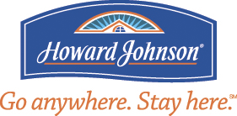

Go Anywhere. Stay Here.SM We’ve gone from 28 flavors of ice cream to over 475 flavors of hotels. Howard Johnson® has a variety of choices to respond to every type of travelers varying needs; Howard Johnson® offers what its guest s need, when they need it, and how they want it! With amenities that include all the Comforts of Home like a 25-inch television, coffeemaker, AM/FM radio, free long-distance access, voicemail, hair dryer, iron ironing board and a free weekday newspaper to its complimentary Rise and Dine breakfast, Howard Johnson® has got you covered.



With more than 2,000 motels throughout North America, and a strategic expansion plan in place for China, chances are that somewhere between where you are and where you are going, there’s a Super 8®. See you along the way TM. All Super 8® motels provide free continental breakfast and high-speed Internet access. Free coffee is available to all travelers whether they are guests or not, when they bring in a Super 8 coffee mug. Participating motels allow pets and offer free local calls, fax and copy services, microwaves, suites, guest laundry, an exercise facility, cribs and rollaway beds. Kids 17 and under stay free with an adult family member.

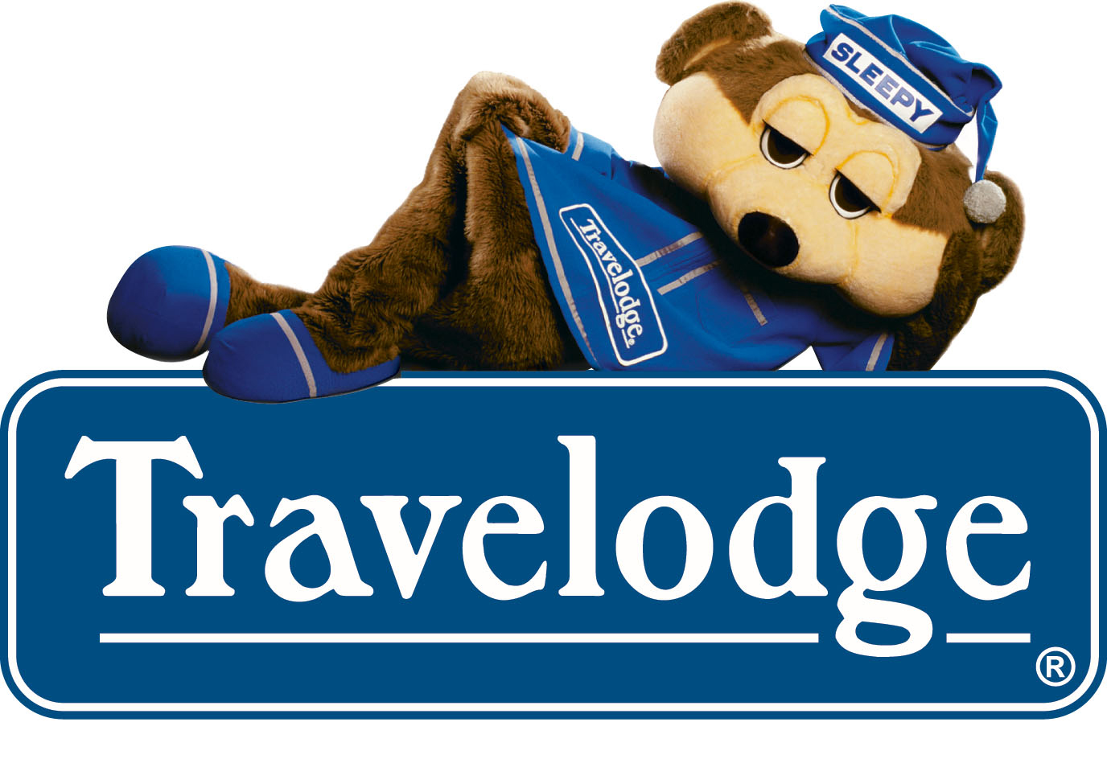

For travelers on a tight budget who love to discover their world without having to spend a lot, Travelodge® is the perfect crash pad when you want to soak up life. It provides the best of the basics. Unlike our econobox competitors, our product was inspired by a bear—to speak to the bear in all of us…reminding us to play hard by day and sleep even harder by night. All Travelodge Hotels, Travelodge, and Travelodge Suites rooms include high-speed Internet, free in-room coffee, complimentary Bear Bites Breakfast where available, free weekday lobby newspaper and rooms with a 25-inch television including free sports, movie and news programming

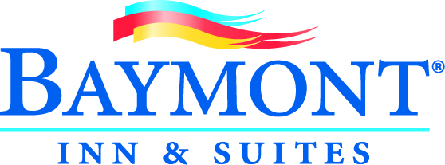

Baymont Inn & Suites® exceptional service with a wide range of popular amenities, at an affordable price offered nationwide, such as: Complimentary continental breakfast featuring waffles and French toast, Free High-speed Internet access (some wireless), Express check-in and check-out, and more. Baymont Inn & Suites® hotels are located in the United States. Each hotel offers free local calls, free long distance access, in-room coffee maker, iron and board, hair dryer and shampoo, television with premium channels, pay-per-view movies and/or satellite movies and video games and express check-in and check-out. Most locations feature swimming pool, fitness center and airport shuttle service at airport locations

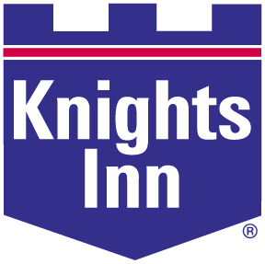

Every Knight, Just Right®. At Knights Inn we pride ourselves on exceeding your expectations through friendly service and exceptional value. And now we have found one more way to make your stay with us as comfortable as possible. After a great night's sleep there's no better way to start the day off right than with a complimentary continental breakfast. Join us for a hot drink, juice and a bite to eat - we'll see you in the morning.

Travel Deals for Members
Now save on rooms at 11 brands and nearly 7,000 participating hotels worldwide.

Hotel Discount Offer
As an associate of Bellarmine University and a member of E and I Cooperative Purchasing you will receive a minimum of 10% off the “Best Available Rate” at participating locations every time you travel. Book online by clicking link below or call and give agent your discount ID number 1000007780 and your institution’s affiliate ID number 000370 at time of booking to receive discount.

Whether you are looking for an upscale hotel, an all-inclusive resort or something more cost-effective, we have the right hotel for you… and at the right price. So start saving now. Call our special member benefits hotline 1-800-525-5501 and reserve your room today at one of these fine hotels:

Wyndham Hotels and Resorts®
Days Inn®
Ramada Worldwide®
Super 8®
Wingate By Wyndham®
Baymont Inns and Suites®
Hawthorn Suites®
Microtel Inns and Suites®
Howard Johnson®
Travelodge®
Knights Inn®

“© 2009 Wyndham Hotel Group, LLC. All hotels are independently owned and operated excluding certain Wyndham and international Ramada hotels which are managed by our affiliate or through a joint venture partner.

“Best Available Rate” is defined as the best, non-qualified, publicly available rate on the Internet for the hotel, date and accommodations requested. The discount for some International properties may be less than or equal to 10% of Best Available Rate. Certain restrictions apply. To redeem this offer, click our URL link on Organization’s website or call the hotel brand phone number above and give ID at the time of reservation. Offer not valid if hotel is called directly, caller must use toll free numbers listed above. Advanced reservations are required. Offer is subject to availability at participating locations and some blackout dates may apply. Offer cannot be combined with any other discounts, offers, or special promotions. Discounts vary by location and time of year. Offer is void where prohibited by law and has no cash value.

