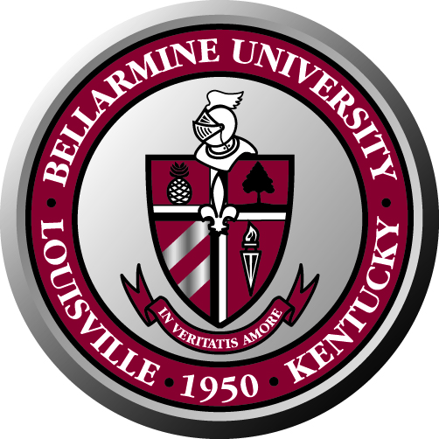
Bellarmine University Staff Council
Minutes of Meeting
February 6, 2009

The Staff Council 2008-2009 met on February 6, 2009 in the Fireplace room.

Attendance:
Present: Ken Lundgren, Marla Smith, Angela Rone, Martha Strobel, Nettie Wilson, Pat Allen, Lucy Burns, Larry Modesty, Debbie Femi, Mary Harper, Rose House, Rita Yates, Renee Hicks, Sherry Pile and Lynn Bynum.
Special guest: Hannah Clayborne

Absent: Ann Reed and Lois Roby

Welcome: The meeting started with a welcome and thank you from Ken Lundgren for helping make December’s Santa Spread a success. He also welcomed Hannah Clayborne to the meeting.

Special guest: Hannah Clayborne attended the meeting to present the Campus Diversity Plan. She distributed copies of the plan and gave a quick introduction of it. She encouraged the staff council to read it. She will be back for our next meeting to review the plan and answer any questions we may have.

Approval of minutes: Approval was needed for minutes from previous meetings: March 13, 2008 Lucy Burns made a motion to approve, seconded by Mary Harper. April 24, 2008 move for approval from Marla Smith and seconded by Rita Yates. November 21, 2008 move to approve after correction of Ken Lundgren’s name in the Bylaws committee from Lucy Burns, seconded by Nettie Wilson.

Committee Reports:

Benefits Committee: Nettie Wilson reported that the Staff Council wanted to extend our thanks to Dr. McGowan for the extra two days given to us during the Christmas Holiday and the opportunity to watch the Presidential Inauguration.

They presented several ideas for feedback on what the council thinks the committee should concentrate on. The committee is looking at getting member discounts at Sam’s Club and Costco; they want to propose a “no increase” in the parking fee for school year 2009-10; install time clocks in all buildings; the removal of the technology fee from staff class registration; offer the following day off to staff recognized at the Staff Recognition party at the president’s house; review staff vacation days; and start an ongoing item collection for the needy throughout campus. This last one would involve the entire campus community.

This last proposal is to contribute all year with items for different groups and working with Campus Ministry for help in collection and distribution. Ideas were discussed such as placing collection boxes in all the buildings. Volunteers would help with the collections and Nettie Wilson will coordinate the effort.

Lucy Burns suggested that this idea be run by the cabinet to make sure it is OK with them and with the university’s mission.

Nettie Wilson and the Benefits committee will bring a full proposal and plan to the next meeting.

Nominations, Elections/Bylaws Committee: Lucy Burns reported that the language of the bylaws is being revised. We want to make sure that the staff is fully represented by the Staff Council with eleven (11) representatives and ten (10) at large members. Bellarmine staff is eligible for council membership after six months of employment, but can vote from day one. Also it is proposed that large areas have two elected representatives.

The proposal suggests that the Staff Council be comprised by the following departments: President’s Office, Information Services, Library, Development and Alumni Relations, Administration and Finance, Facilities Management, Academic Affairs, Enrollment Management, Student Affairs, Communications and Public Affairs, and Athletics. Each area will elect a representative. The remaining ten representatives will be elected “at-large.”

The new Bylaws will be presented for approval at the next meeting.

Due to the fact that this year’s elections were held in August instead of April, Lynn Bynum proposed that the current Staff Council serve a term until April 2010. This extended period will give the Staff Council time to do all the work proposed. Elections should be set for March 2010. There will be a special election for at-large representatives for vacant spots, like the library, which is not currently represented due to Ted Palmer’s departure.

Staff Development and Social Community: The committee hasn’t met due to travel to the inauguration and the winter storm. They are open for ideas. Please send Angela Rone any ideas.

Open Items:

Mary Harper asks what proposal from the Benefits Committee should be pursued: the Friday after the recognition party off, or the ongoing donations proposal. It was decided that the donations is the project we are going to pursue this year. It is more important and it will take more time to plan and implement.

Announcements:

Lynn Bynum announced that the TIAA Cref workshops were going to be held on February 13th to inform and answer questions on the current market. She encouraged all staff to attend.

The current Staff Council photo was taken and it can be viewed on the Staff Council website.

Adjourn:

The next meeting will be held either late March or early April. The election for at-large representatives will be held then.

With no further business, the meeting ended at 11:00 a.m.

