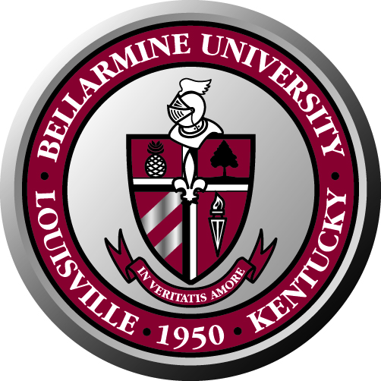
Bellarmine University Staff Council
Minutes of Meeting, April 24, 2008

The Bellarmine Staff Council met April 21, 2008 at 10a.m. in the Fireplace Room of Horrigan Hall.

Present: Chair Jared Burton, Vice Chair Ken Lundgren, Allison Becker, Cornell Craig, Maria Gonzalez, Rose House, Sherry Pile, Sharon Raney, Lois Roby, Jennifer Schum, Marla Smith and Rita Yates, Larry Modesty, Lucy Burns, Nettie Wilson, Lynn Bynum.

Absent: Beth Davis, Ted Palmer, Ann Reed, Renee Hicks and Heather Snow

Chair Jared Burton welcomed the committee opened the meeting with a prayer. The minutes were approved as written.

Lynn Bynum announced that the university will close at noon on Fridays for “summer hours” beginning June 13 for eight weeks. The university will close at noon on July 3rd. Like last year, if these hours present a problem, employees should work out an alternate plan with their supervisors. Lynn will send out an email announcing this to campus.

Jared Burton reported that the lost key policy is under review and recommendations have been made to reduce the amount charged from $200 to $100. An announcement will be made when the decision is final. Jared and Lynn Bynum met to discuss the bylaws and made their recommendations to President McGowan.

Jared’s term as Staff Council chair will end in May and Ken Lundgren’s term will begin. More information about elections will come soon. Members will be asked if they wish to continue.

Allison Becker said that the newsletter is out and thanked Maria Gonzalez and Beth Davis for their help with the newsletter and website.

Jennifer Schum reported that the staff potluck was cancelled due to low response. The staff picnic will be held on May 12, 11:30 a.m. to 2 p.m. This will be a campus-wide event to celebrate Bellarmine’s award as one of the best places to work. Offices will be closed so that everyone can attend. She also stated that Bellarmine Day at the Downs will be in June.

The benefits committee worked with Lynn Bynum to revise the short term disability policy. An announcement will be coming soon.

The date for the next meeting has not yet been determined.

