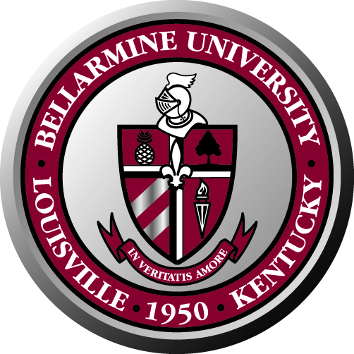
Bellarmine University Staff Council
Minutes of Meeting
November 21, 2008

The staff council 2008-2009 met for the first time on November 21, 2008 in the Fireplace room.

Attendance:
Present: Ken Lundgren, Rita Yates, Nettie Wilson, Pat Allen, Debbie Femi, Angela Rone, Lucy Burns, Larry Modesty, Sherry Pile, Martha Strobel, Ann Reed, Rose House and Lynn Bynum.

Absent: Renee Hicks, Lois Roby, Marla Smith and Mary Harper.

The meeting started with a prayer. Ken Lundgren welcomed all the new members of the council.

First order of business was to elect the Vice Chair and Secretary for the next year. Elected were Ann Reed as vice chair and Maria González as secretary.

The main goal for this year is to revise and amend the Staff Council Bylaws to make sure they represent all employees of the university. Once this is done, they will be sent to Dr. McGowan for revisions and approval.

The committees for this year were formed. They are as follows:

Coordinating Committee: Ken Lundgren, Ann Reed, Maria González and the chair of each committee

Nominations/ Elections/ Bylaws: Lucy Burns (chair), Ann Reed, Ken Lundgren, Rita Yates, Lois Roby

Staff Development Committee/ Social and Community Activities Committee: Angela Rone (chair), Pat Allen, Debbie Femi, and Rita Yates

Employment Affairs/ Benefits Committee: Nettie Wilson (chair), Larry Modesty, Sherry Pile, Marla Smith, Mary Harper

Communications Committee: Maria González (chair), Rose House, Martha Strobel, Renee Hicks

Other business:

Santa Spread for this year will be on December 10th, 11 a.m. – 1 p.m. in Hilary’s.

The next Staff Council meeting will be on Friday, January 30th, at 10:00 a.m. in the Fireplace Room.

Adjournment:

With no other business to discuss, the meeting was adjourned at 11:30 a.m.

