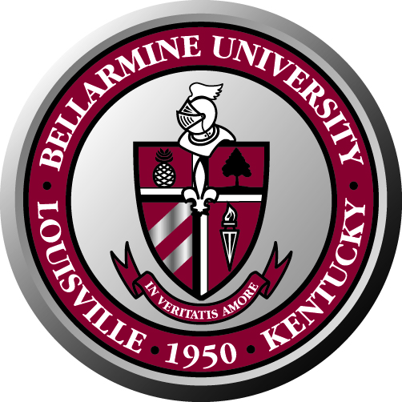
Bellarmine University Staff Council
Minutes of Meeting
May 14, 2010

The Staff Council 2009-2010 met on May 14, 2010 in the Fireplace room. The Staff Council for 2010-2011 was also in attendance.

Attendance:
Present: Ken Lundgren, Nettie Wilson, Lynn Bynum, Marla Smith, Martha Strobel, Debbie Femi, Angela Rone, María González, Traci Tignor, Jennifer Likes, Mary Harper, Brad Bluestone, Hannah Clayborne, Kim Sears, Ryan Simpson, Patrick Englert, Jyll O’Shea, Martha Thomas, Tracey Cox, Mary Hamilton.

Absent: Renee Hicks, Larry Modesty, Rose House, Pat Allen, Lois Roby, Chris Paulley, Carla Carlton, Lucy Burns, Sherry Pile.

Welcome: The meeting started with a welcome from Ken Lundgren. Ken also thanked all the new members for volunteering to participate in the Staff Council. He also thanked the members who were rotating off the council for their service and hard work.

Special Guest: Erica Jones, director of Development and Annual Giving. She talked about donations to the university and getting alumni participation. The more alumni participation, the more support to the university.

Ken offered a bylaws overview. He explained that the current document is a draft that was presented to Dr. McGowan and the board, but it has not been approved. Ken explained the role of the Chair, Vice-chair and Secretary.

Approval of Minutes: Marla Smith moved to approve the minutes from the October 28, 2009 meeting. Debbie Femi seconded the motion. The minutes were approved without changes.

Meeting discussions:

Committee Reports: This time each committee chair gave an overview of their committee and shared what they are working on for the future.

Bylaws Committee: Ken reported that the council is still missing representatives from the Library and Academic Affairs. He is trying to get staff members to volunteer for both positions. He encouraged members to go to their departments and get ideas and concerns for the staff council to work on.

Social and Development Committee:
- Staff council picnic is scheduled for June 3, 11 a.m. – 2 p.m. in the Quad
- Organized the cook-off and bake-off. Both events were a big success. There are plans to have both events in the future.
- The committee works to bring the community together with fun and exciting events

Benefits Committee:
- Works on advising HR on benefits for the staff
- Worked on continuing with the summer hours

Communications Committee:
- The committee works to help spread the word on what is going on on campus using Bellarmine Today and the Staff Council Newsletter. Members were asked for help with contributions for the Staff Council Newsletter when the announcement goes out.
- The new Staff Council Newsletter is in the works and will go out before the end of the week.
- The website will be updated with the new Staff Council members.

Lynn Bynum:
- Happy to report that it was a very successful open enrollment event. They held more than 100 individual consultations. A good number of employees signed up for the new HDHP plan. This year more people were interested in benefits and the new choices offered.
- In June there will be a new TIAA-CREF investment options roll-out. There will be new mutual funds, IRAs, etc. There will be information sessions offered for all employees.
- HR wants to work with the Benefits Committee to come up with ideas to help celebrate and recognize employees’ years of service.

Elections were held to choose the new coordinating committee. The new chair is Debbie Femi. The new Vice-chair is Tracey Cox and the new Secretary is Mary Hamilton.

The new Staff Council members chose the committees they want to participate in and had quick meetings to start getting organized.

The photo of the sitting Staff Council was taken and will be posted on the webpage.

Meeting was adjourned at 11:10 a.m.

