EDUCATION FOR LIBERATION OR DOMINATION?:
A CRITICAL ENCOUNTER IN JAMAICA
IDC 301 F
SPRING 2009

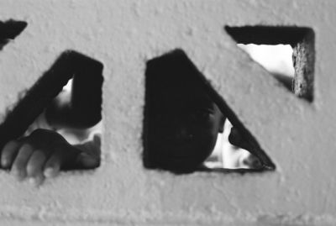

Bellarmine Mission
Bellarmine University is an independent Catholic university serving the region, nation and world by educating talented, diverse students of all faiths and many ages, nations, and cultures, and with respect for each individual's intrinsic value and dignity. We educate our students through undergraduate and graduate programs in the liberal arts and professional studies, within which students develop the intellectual, moral, ethical and professional competencies for successful living, work, leadership and service to others. We achieve these goals in an educational environment committed to excellence, academic freedom, and authentic conversations not dominated by particular political or other single perspective and thus to thoughtful, informed consideration of serious ideas, values, and issues, time-honored and contemporary, across a broad range of compelling regional, national and international matters. By these means, Bellarmine seeks to benefit the public interest, to help create the future, and to improve the human condition. Thus we strive to be worthy of our foundational motto: In Veritatis Amore, In the Love of Truth.

Instructor: Sonya Burton Gina Stiens Adam Renner
Office: BOB 315 Alumni … BOB 306
Phone: 452-8339 (o) 596-1242 (o) 452-8135 (o)
533-0070 (c) 513-673-2681(c) 513-673-2672 (c)
Email: sburton@bellarmine.edu gstiens@bellarmine.edu arenner@bellarmine.edu
Office Hours: Tuesdays 11:30-1:30, Fridays 12:30-1:30, Mondays 8:30-11:30;
3:30-5:30, and by and by appointment Tuesdays/Thursdays 3:00-4:00;
appointment Fridays 12-1; and by
appointment

TEXTS:

Readings will be made available to students, and
The Longman Writer’s Companion

COURSE DESCRIPTION:
[IDC 301 is] designed to provide students with strong interdisciplinary study of cultures beyond that of the United States. Each course offering is studied through approaches provided by more than one discipline of thought. For example, a course on Latin American Culture and Civilization might approach its subject through art, music, and history; another might combine the disciplines of theology, history, and art in studying the lives of St. Francis and St. Robert Bellarmine and the Italian culture that frames their work. This course builds on and further develops the set of skills/abilities introduced in IDC.101/200, culminating with a final project that combines research and critical analysis, emphasizing the critical analysis component of the project (p. 213, 2007-2009 Catalogue).

This course will build upon an already existing partnership with Jamaican schools and social service organizations. Through problem posing, students and instructors will explore historical, social, economic, and global factors that determine whether, and to what extent, education is a practice of domination or liberation. We will also explore the complexities of power relationships, such as between teacher/student and global north/south. Using a critical lens, students will also examine the notion of education, comparing their ideas & theories of education in Kentucky schools with education in Jamaican schools. Further questions that may be explored are what is education? Why do we need it? Who benefits from education? What would a truly solidaristic and liberatory relationship look like?

This class will be a little different than most in your educational experience. It is not only a course outside of your major, but it is one in which there is an international service learning experience tethered to it. And, it is one in which you make up the bulk of the curriculum. That is, this course is about you: you coming to a more critical consciousness of the world around you, you coming to a more constructive self-awareness of how you take part in the process of social justice, and you coming to a more nuanced understanding of a history that has brought us to this current national/global condition of poverty, racism, and patriarchy. This class, grounded in an experience abroad, will be successful to the extent that we are able to build community--among ourselves and with our Jamaican service partners—as well as deepen our consciousness about issues of social justice. The bulk of the curriculum for this course will incorporate collaboration—to learn more about our world and to try to begin to make sense of it together—and will cover topics, broadly conceived as: globalization, purposes of education, history/sociology/economics of Jamaica, privilege/oppression, and critical literacy. There is no body of information that must be memorized during this semester for you to be successful. You will most certainly not be made to regurgitate anything we say (or believe). Instead, steeped in the topics above, (y)our success will be based on the extent to which we/you are able to grow in (y)our ability to think and act for others , as well as live more authentic/connected/compassionate lives.

Our class meetings will cover both the theoretical (history, sociology, economics of Jamaica; critical approaches to service learning; critical literacy, etc.) and the practical (what we will actually do with our partners in Jamaica, fundraising, etc.). These class meetings will model the kind of collaboration we hope to have with our partners. And, these class meetings will necessitate that you come prepared each and every time--having read the material, grappled with it, and made yourself ready to engage in deep discussion with your peers.

We greatly look forward to our work together in the spring. We hope it represents the best of university education experiences. This work has been a life-changing and ever-evolving experience for us. We presume it will be for you too.
This course has a required field experience that will take place in Montego Bay, Jamaica from June 1 through June 10, 2009. There is also a course fee for travel expenses of approximately $1300. Some fundraising possible.

COURSE METHODOLOGY
This course adheres to a socially reconstructionist philosophy, grounded in a critical, engaged, and problem-posing pedagogical approach to inquiry and teaching. We will be required to deeply examine our beliefs about social difference and social justice. This examination (through readings, discussions, field work, writing, collaboration, and reflection) will begin where we are. Continuous assessment and reflection will reveal to what extent we have critically shifted/evolved in our thinking.

IDC SKILLS and GENERAL ED OBJECTIVES:
See http://www.bellarmine.edu/faculty/arenner/idc/Course%20Prep.htm

LEARNER OBJECTIVES:
- We will build community by participating in readings and conversation thereby developing more critical thinking skills and a deepening consciousness of social issues.
- We will describe the basic tenets of corporate globalization as seen through the lens/context of Jamaica
- We will analyze the political nature of as well as the extent to which education is or is not neutral
- We will examine the role that historical, social, economic, and religious influences have on our perceptions and actions thereby comprehending our socialization and control over it.
- We will implement our constructed understanding of critical literacy
- We will demonstrate an enhanced cultural competency (QEP Goal 2)
- We will “apply a global perspective to analyses of social, economic, political, and environmental issues” (QEP Goal 4).
- We will exhibit an increased understanding of physical and human geography.

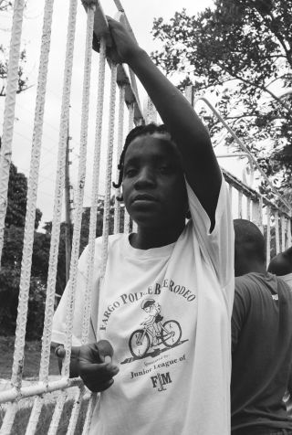

ASSESSMENT:

Attendance (100 points)

You are expected to be a thoughtful, active, and informed member of class discussions, lectures, individual presentations, and group activities. You are also expected to attend each class session, arrive punctually, and be prepared by having read the required assignments. Of course, circumstances beyond our control will arise during the semester and cause an absence. Our attendance policy, therefore, is as follows: One absence for any reason is totally forgiven. A second absence, which must be excused will result in a reduction of 30 points from this grade. A third absence, which also must be excused will result in a 60 point loss from this grade. A fourth absence will result in a total loss of the attendance grade. A fifth absence will constitute failure of the course.

The University requires students who will be absent from class while representing the University to inform their instructors in two steps. During the first week of the course, students must meet with each instructor to discuss the attendance policy and arrangements for absences related to University-sponsored events. Second, students must provide the instructor with a signed Student Absentee Notification Form, available via the student portal on the University intranet, at the earliest possible opportunity, but not later than the week prior to the anticipated absence. The Student Absentee Notification Form does not serve as an excused absence from class. Your instructor has the final say about excused and unexcused absences and it is the student’s responsibility to know and abide by the instructor’s policy.

Participation (200 points)

As your physical presence makes up a total of one hundred points of your grade, two hundred additional points of your grade will be comprised of your participation. This grade will be negotiated between the instructors and the student toward the end of the semester. The participation grade will be based on your in class work, online work relative to Bb, exit cards, and participation in planning the itinerary for the trip. In order to achieve an “A” in participation, students, at a minimum, must demonstrate critical engagement with the material and their colleagues in all areas. It will be up to the student to be visible and vocal in their participation. Students should be prepared to advocate for their participation grade using the items above as evidence. Students may also consult with the professor at any time during the course regarding their progress in participation. This is strongly encouraged. See the participation rubric at: http://www.bellarmine.edu/faculty/arenner/idc/assessment%20version%202.htm for a good idea of participation expectation.

Paper 1: Research paper (300/425 points for seniors)—due May 1

Exact assignment to be developed with students.
Non-negotiable elements include:
- 10-15 written pages
- research-based, using a minimum of 5 sources
- use of critical lens (argument of rigorously researched position)
- topics to include issues such as (but not limited to): globalization, education, critical literacy, context of Jamaica…

(See writing/ research rubric at: http://www.bellarmine.edu/faculty/arenner/idc/assessment%20version%202.htm)

In-class writing prompts (75 points; 25 points each)

On demand writing prompts that cover recently read/discussed material

Critical literacy demonstration (200 points)—due May 1

- Project will be an outgrowth of modeling provided by professors and theoretical work we will cover in our readings
- Completed in groups of 3-5 (all members must participate in preparation and presentation)
- Models tenets of critical literacy by leading class discussion through use of picture(s), cartoons, children’s reading, poem, short story, reading, song lyrics, etc.
- Should connect to work we will actually do in Jamaica (e.g., at Wee Care Basic School, as a team, with other Jamaican professionals, etc.)
- Final project assignment/rubric will be completed by class

Paper 2: Service reflection (125 points)—due June 24

Exact assignment (and rubric) to be determined with students.
Non-negotiable elements include:
- At least 8 pages in length
- Connection to research paper, newly steeped in the experience in Jamaica
- Critical lens as seen through a “minority-position perspective”
- Demonstrates an enhanced cultural competency and understanding of human geography
- Deconstructs socialization
- Takes a shot at answering the course question: Education for liberation or domination?

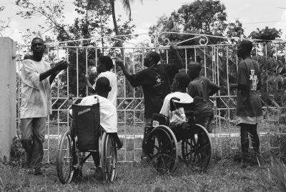

Assessment | Learner Objective | Gen Ed Goal | IDC Skill
Attendance | 1, 4 |  | Seminar
Participation | 1, 4, 6 | 9, 10 | Writing, Reading, Speaking, Seminar, Technology
Paper 1: Research | 2, 3, 4, 7 | 3, 9, 10 | Writing, Reading, Technology, Research
Paper 2: Service Reflection | 1, 4, 6, 7, 8 | 3, 9, 10 | Writing, Reading, Speaking, Technology, Research
In-class writing prompts | 2, 3, 5, 7, 8 | 3, 9, 10 | Writing, Reading
Critical literacy demonstration | 1, 4, 5, 6, 7 | 9,10 | Reading, Speaking, Seminar

GRADES:

A 940-1000 B+ 880-899 C+ 780-799 F <700
A- 900-939 B 840-879 C 740-779 B- 800-839 C- 700-739

SEVERE WEATHER:
Refer to the current student handbook for details regarding changes in schedule due to bad weather. Faculty will arrange class schedules to meet course objectives in the event classes will be cancelled.

ACADEMIC HONESTY:
I strongly endorse and will follow the academic honesty policy as published in Bellarmine’s Catalog 2007-2009 (pp. 48-49) and in the 2007-2008 Student Handbook (pp. 16-19); both documents are available online via the student portal on the University’s intranet. Students must be fully aware of what constitutes academic dishonesty; claims of ignorance cannot be used to justify or rationalize dishonest acts. Academic dishonesty can take a number of forms, including but not limited to cheating, plagiarism, fabrication, aiding and abetting, multiple submissions, obtaining unfair advantage, and unauthorized access to academic or administrative systems or information. Definitions of each of these forms of academic dishonesty are provided in the academic honesty section of the 2007-2008 Student Handbook. All detected instances of academic dishonesty will be reported to the Senior Vice President for Academic Affairs, and sanctions will be imposed as dictated by the policy. Penalties range from failing an assignment or test to dismissal from the University, depending, in part, on the student’s previous record of academic dishonesty. On the second offense during a student’s academic career, as a minimum additional penalty, the SVPAA will immediately suspend the student for the semester in which the most recent offense took place. On the third offense, the SVPAA will immediately dismiss the student from the University.

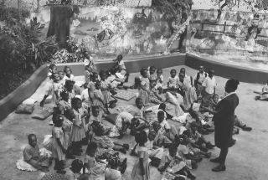

ACADEMIC RESOURCE CENTER (ARC):
Bellarmine University is committed to providing services and programs that assist all students in further developing their learning and study skills and in reaching their academic goals. Students needing or wanting additional and/or specialized assistance related to study techniques, writing, time management, tutoring, test-taking strategies, etc., should seek out the resources of the ARC, located on the A-level of the W.L. Lyons Brown Library. Call 452-8071 for more information.

DISABILITY SERVICES:
Students with disabilities who require accommodations (academic adjustments and/or auxiliary aids or services) for this course must contact the Disability Services Coordinator. Please do not request accommodations directly from the professor. The Disability Services Coordinator is located in the Counseling Center, phone 452-8480.

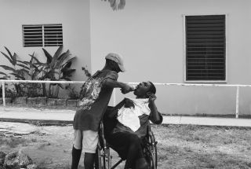

TENTATIVE COURSE CALENDAR (Calendar is subject to change where identified by the instructor an/or as agreed to by the class and the instructor)

Date | Topic | Readings & Assignments
Jan 9^{th (2:00- 3:00)} | Introductions/ Expectations/ | Poem: “Not So Soft” (DiFranco); “A decade of work in the Global South” (Stiens and Renner) (Bb discussion)
Jan 16th | Itinerary planning; context of Jamaica | Renner (Exploring the context: Mapping the cultural landscapes of Jamaica)
Jan 23rd | Film: Life and Debt | Readings on globalization, Targ and Cormier, and Rethinking Globalization (Bb discussion)
Jan 30th | Film: Life and Debt | Readings on globalization, TBA from Alternatives to Economic Globalization
Feb 6th | Gender and the Global South | “The Gendered Politics and Violence of Structural Adjustment” (Faye Harrison)
Feb 13^{th (2:00- 3:00)} | In class writing prompt; Itinerary planning
Feb 20th | Social service vs. Social change | Readings from Kivel (Social service vs. social change) and Farmer (Chapter 5 from Pathologies of Power)
Feb 27th | Socialization | Gorski (A Decolonizing Intercultural Education) and Harro (The cycle of socialization)
March 6th | Spring Break!!!
March 13^{th (2:00- 3:00)} | In class writing prompt; Itinerary planning | Freire (Chapter 4 of Pedagogy of the Oppressed) (Bb discussion)
March 20th | Critical literacy | Shor (What is critical literacy?) and Shor (Education is politics: An agenda for empowerment)
March 27th | Critical literacy | Shor (Rethinking Knowledge and Society: Desocialization and Critical Consciousness) and Berlin (Students Re-writing culture)
April 3rd | Visit from PT group | Reading on Medicine as a Human Right from PT group
April 10th | Easter Break!!!
April 17^{th (2:00- 3:00)} | In class writing prompt; Itinerary planning | Auerbach (Teacher tell me what to do) (Bb discussion)
April 24th | ???
May 1st (11:30-2:30) | Final Exam: Critical literacy demo; Paper 1 due; final discussion
June 1-June 10 | Jamaica | Poetry TBA
June 24 | Paper 2 due

