Basic Ecology

http://www.wwtlearn.org.uk/index0.html?factfile/five-secrets-life.htm&2

Summary
This factfile introduces the concept of ecology - the interrelationships between
species and their environments. It does this through a simple mnemonic -
the E and 4Cs of life (energy, cycles, conditions, communities, change).

How the world works
The story of how the world works can be summarized in a simple phrase: the E and 4Cs of life. This is the basis of ecology, the study of relationships between animals (including people), plants, other organisms and their surroundings.
E - energy
The single most essential requirement for living things, Without it, cells cannot work and all biological processes stop. The ultimate source of energy for life on Earth is the sun. Plants soak up the sun's rays, breathe in carbon dioxide, absorb water, make food products, and breathe out oxygen in the process known as photosynthesis.
In ecological terms, green plants are producers. They are linked to the sun by an invisible chain of energy. Even so, they can only access and use about 10% of the solar energy available to them.
Animals can tap into even less.
Plant-eating animals or herbivores make use of 10% of plant energy (ie a tenth of a tenth, so 1% of solar energy).
Animals that eat other animals (carnivores) receive a tenth of herbivore energy (so 0.1% of solar energy).
Animals are consumers. Herbivores are primary consumers and carnivores are secondary or tertiary consumers.
Other feeding categories include omnivores who eat plant and animal material, and decomposers, especially bacteria and fungi, who feed on dead producers and consumers.
In this way, all life is linked in food chains and webs. Energy flows along the chains in one direction from the sun. At each link in the chain, there is energy loss.
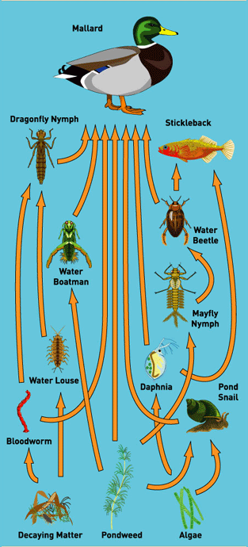 | 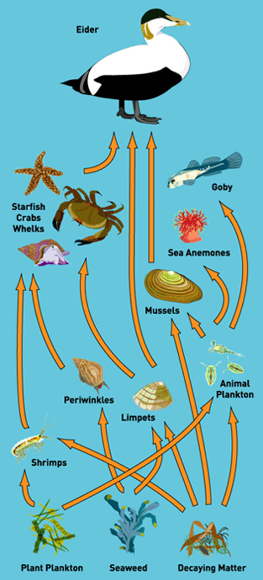
Foodweb
Illustration of a food chain - sun - algae (photosynthesizing producer), Daphnia (primary consumer), stickleback (secondary consumer), heron (tertiary consumer)
C - Cycles
In nature, nothing is lost - it just goes round in cycles as raw materials are reused. There are water cycles, carbon cycles, life cycles, seasonal growth cycles and more.
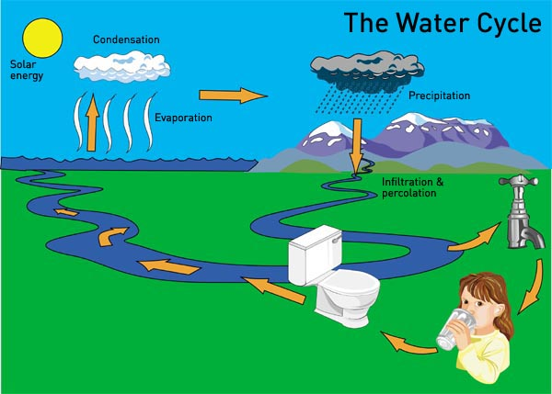
Water cycle
- Rain drops form as clouds meet cold air over high ground.
- Rain falls on the ground. Some falls in mountain streams .
- Mountain streams merge into ever larger rivers which carry water to the sea.
- A small amount of water that drains from the mountains evaporates and begins to form new clouds.
- Seawater evaporates to form new clouds and the cycle begins again.
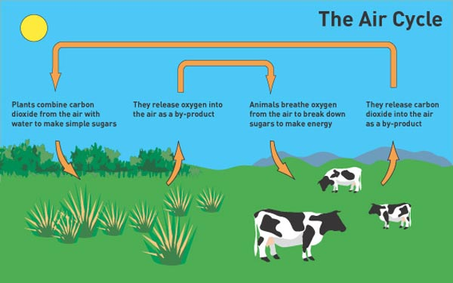
Air, another of our planet's essential resources, is also being constantly recycled.
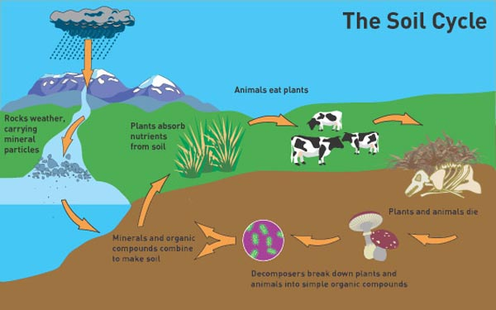
Soils are recycled when living things die and decompose. Chemical processes and weather change minerals and rocks.
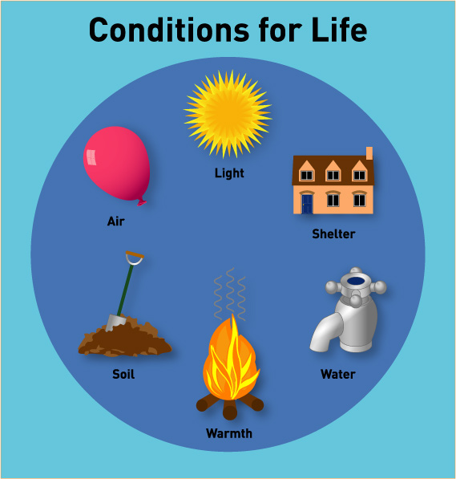
C - Conditions
All living things need special conditions of water, air, warmth, light, soil and shelter to survive. The amounts of these conditions vary from place to place so that different habitats are formed with their own special plants and animals.
C - Communities
Within habitats, species form communities of eating and being eaten.
C - Change
The one constant of life is that everything changes. Individuals are born, grow, breed, age and die. Species' populations change. Habitats change - if left alone, UK wetlands turn into woodland through a process called succession. Species evolve over geological time.
People are the biggest causes of change - think about it.
The American ecologist, Barry Commoner, summed up the story of life as four rules:
- Everything is connected to everything else.
- Everything must go somewhere.
- Nature knows best.
- There's no such thing as a free lunch.
Further reading
Why Big Fierce Animals are Rare. P. Colinvaux (Penguin, 1981).
Ecology for Beginners. S. Croall and W. Rankin (Icon, first published 1982).
Living in the Environment - principles, connections and solutions. G.T. Miller (Wadsworth,1996).
Global Ecology. C. Tudge (Oxford University Press, 1991).
For many more books about ecology, check out www.nhbs.com
 |  | 

